When using the GUI to delete mounted clones, the following options are not enforced apparently:
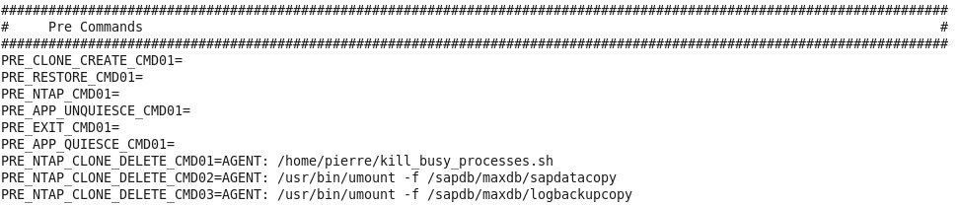
Content of script /home/pierre/kill_busy_processes.sh on SAP host:
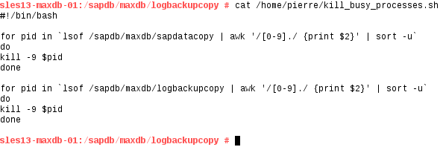
For instance, a snapshot is mounted as a clone using SnapCreator:
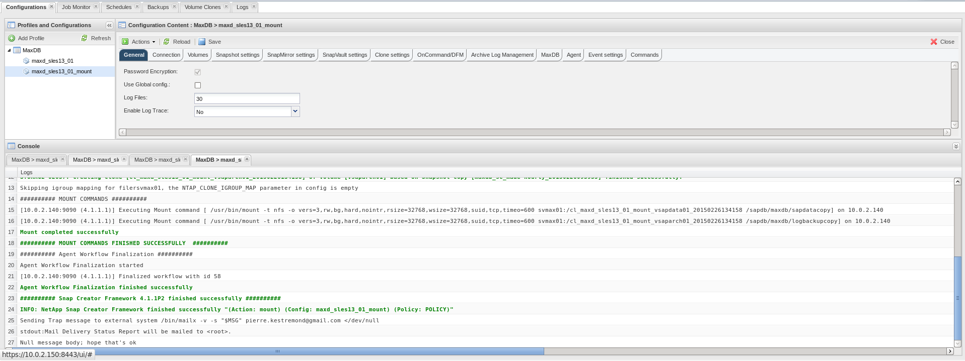
Clones appear in SC GUI:
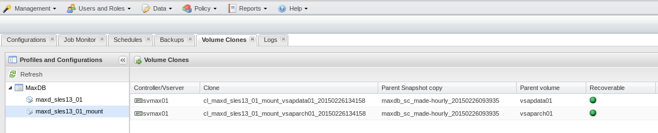
And are mounted as expected on the SAP host, using the following MOUNT_CMDnn parameters:
(On the SAP host:)
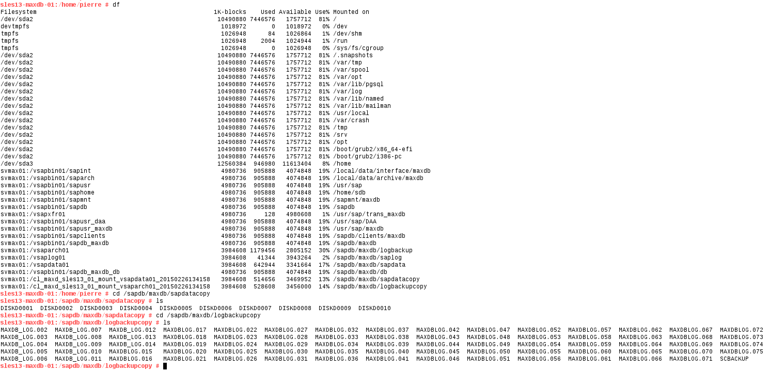
Now let’s say I have finished with restore/recovery operations, and I want to delete my clones using the SC GUI:
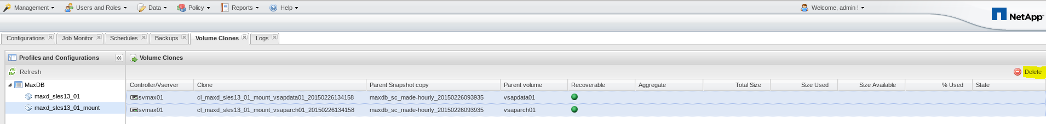
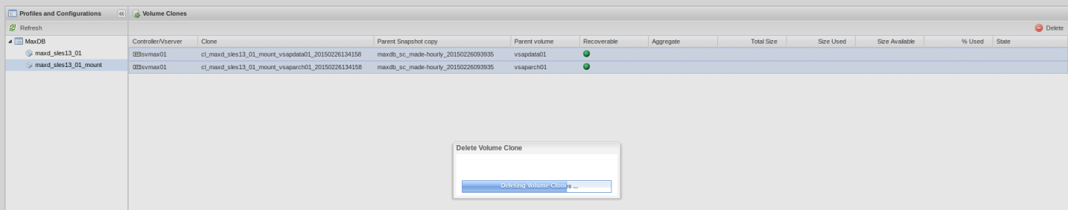
The result on the SAP host is a “stale file handle”, as shown here:
Flexclone Volumes still appear as mounted, and have to be forced unmounted to clean up:
