DataOnTap Upgrade
software update http://10.31.136.117/ontap/814P1_q_image.tgz -r
download and install software 1 node at a time

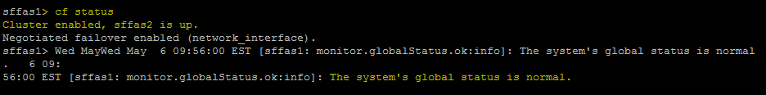
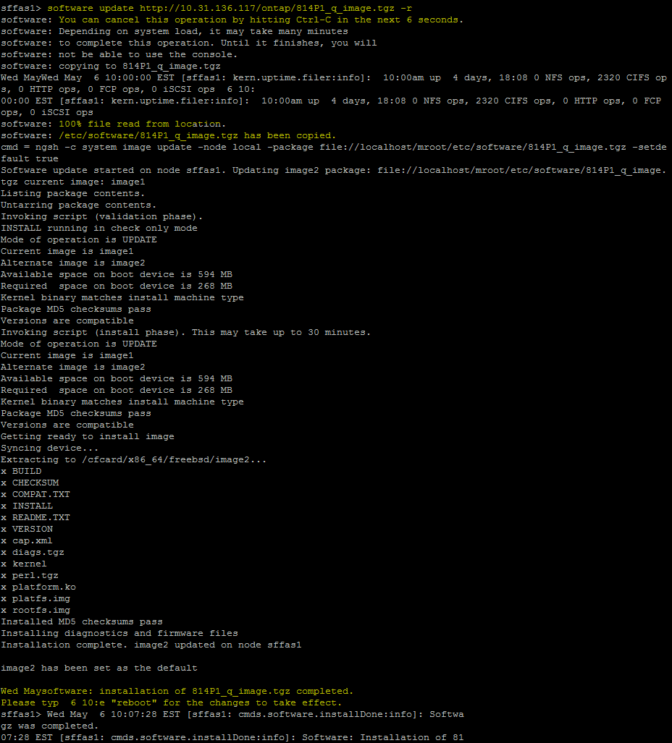
Now start the install on the second node,
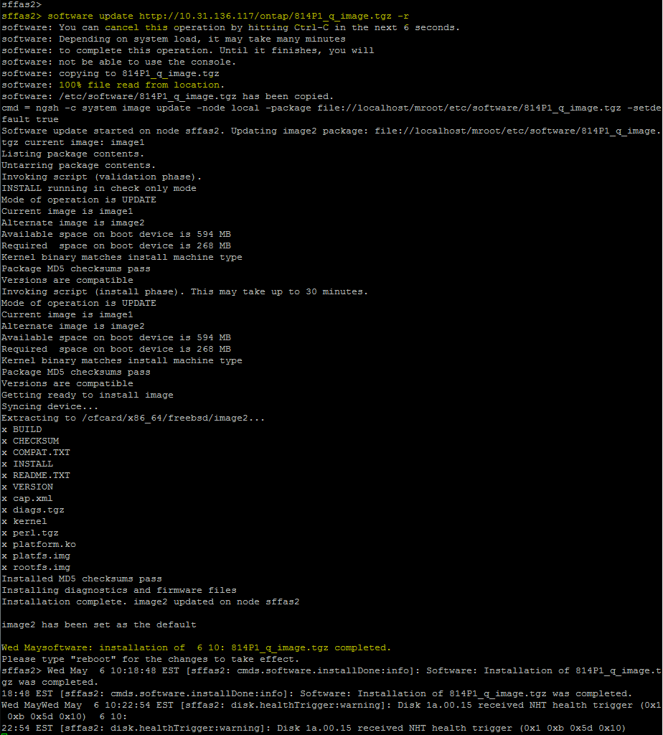

Now you can do a cf take from 1 node to another and repeat back, upon you can see the new version is loaded. Let the system sit for 10 minutes between each take over and give back.

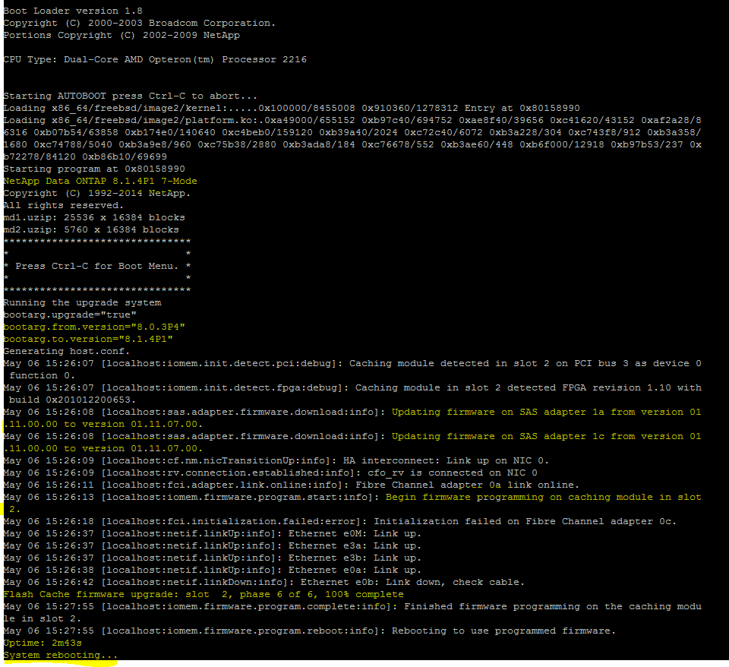
Sfas1 booted into new version and waiting for give back
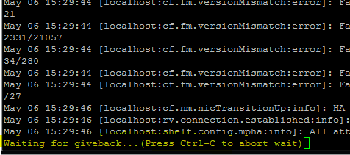
Wait for a few minutes to settle down and perform giveback options (we had to use the –f option because there are existing failed disks in the system)
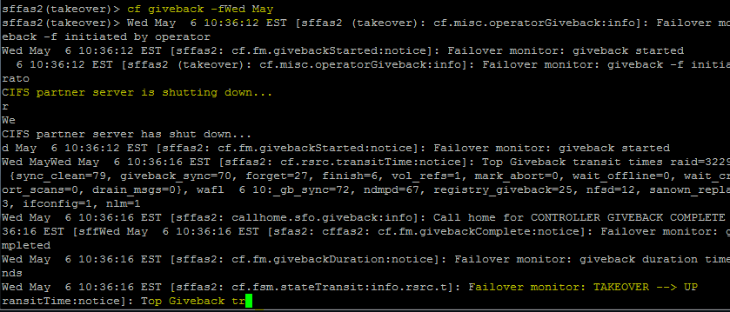
Ok to ignore the version mismatch error
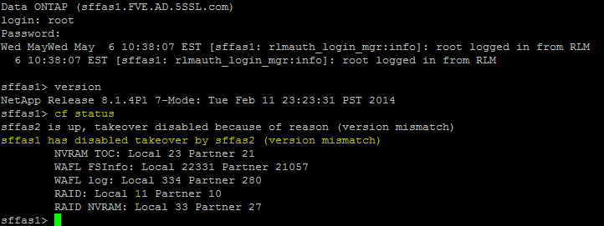
Perform takeover from sffas1 with a “cf forcetakeover” option.
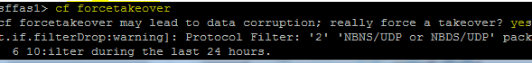
Sffas2 will reboot into upgrade and update system with other firmware.

In this case sffas2 panic and went down into panic
