Network interface show on first controller:
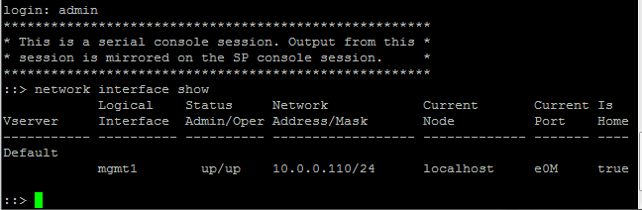
Port config on first controller
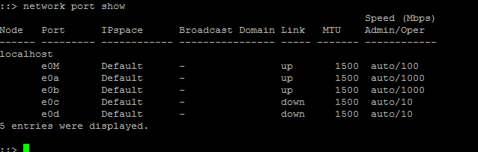
Interface config on the second:
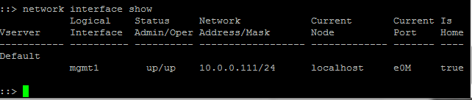
Port config on the second controller:
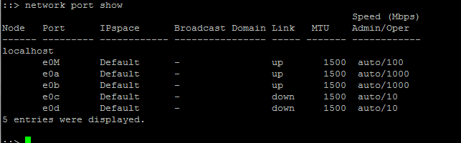
e0M on both controllers go to management switch,
e0a,e0b on both controllers go to data network switch.

