Storage Consumption Workflows
Mrunal Modi

Table of Contents
1 Introduction 4
1.1 Disclaimer 4
2 Unified Provisioning & Protection 5
2.1 Install Procedures 5
2.2 Consumption Procedures 5
3 Operational Procedures 6
3.1 WFA Setup 6
3.2 Import Workflow 6
3.3 Update Existing Data source Types 7
Appendix 1. Resources 8

List of Tables
Table 1) Install Procedures 5
Table 2) Consumption Procedures 5
Table 3) WFA Setup 6
Table 4) Import Workflow 6
Table 5) Update Existing Data Source Types - PlatformDetails and ProtectionDetails 7

List of Figures
No table of figures entries found.
In your document, select the words to include in the table of contents, and then on the Home tab, under Styles, click a heading style. Repeat for each heading that you want to include, and then insert the table of contents in your document. To manually create a table of contents, on the Document Elements tab, under Table of Contents, point to a style and then click the down arrow button. Click one of the styles under Manual Table of Contents, and then type the entries manually.

Introduction

Disclaimer
As you can understand, this workflow is created for general purpose use in the community space and so the following disclaimer applies:
- The workflow is not supported by NetApp Global Support.
- Customers are responsible for ensuring by independent verification its accuracy, currency or completeness.

Unified Provisioning & Protection

Install Procedures
Table 1) Install Procedures
Step | Action
Ensure WFA is setup to acquire data form OCUM 6 (Refer section 3.1)
Note: Wait for WFA to acquire data from OCUM ~ 20 Minutes.
 | Import Workflow & associated Data Source (Refer section 3.2)

Consumption Procedures
Note: Refer to section 3.3, if require updating service catalogue options available out of the box.
Table 2) Consumption Procedures
Step | Action
 | Provision Protection Policies & Schedules using the Protection Workflow
 | Provision storage units using the Provisioning Workflow

Operational Procedures

WFA Setup
Table 3) WFA Setup
Step | Action
WFA Portal > Administration > Setup Wizard > Select OCUM 6.0
Enter admin user within OCUM and Cluster credentials.
Reduce the WFA interval (e.g. 5 min) to refresh data from its MySQL internal database.
WFA Portal > Execution Tab > Data Sources > Initial DFM > Right Click > Edit

Import Workflow
Table 4) Import Workflow
Step | Action
WFA Portal > Administration > Import
ScriptDataProviderType_Customer_Details_1_0.dar
Workflow_Modi_cDot_Provisioning_Service_10Jan2017.dar.zip
Workflow_Modi_cDot_Protection_Service_09Dec2013.dar.zip
WFA Portal > Execution Tab > Data Sources > New > Customer Datasource
- Select Data Source Type “Customer Details – 1.0”
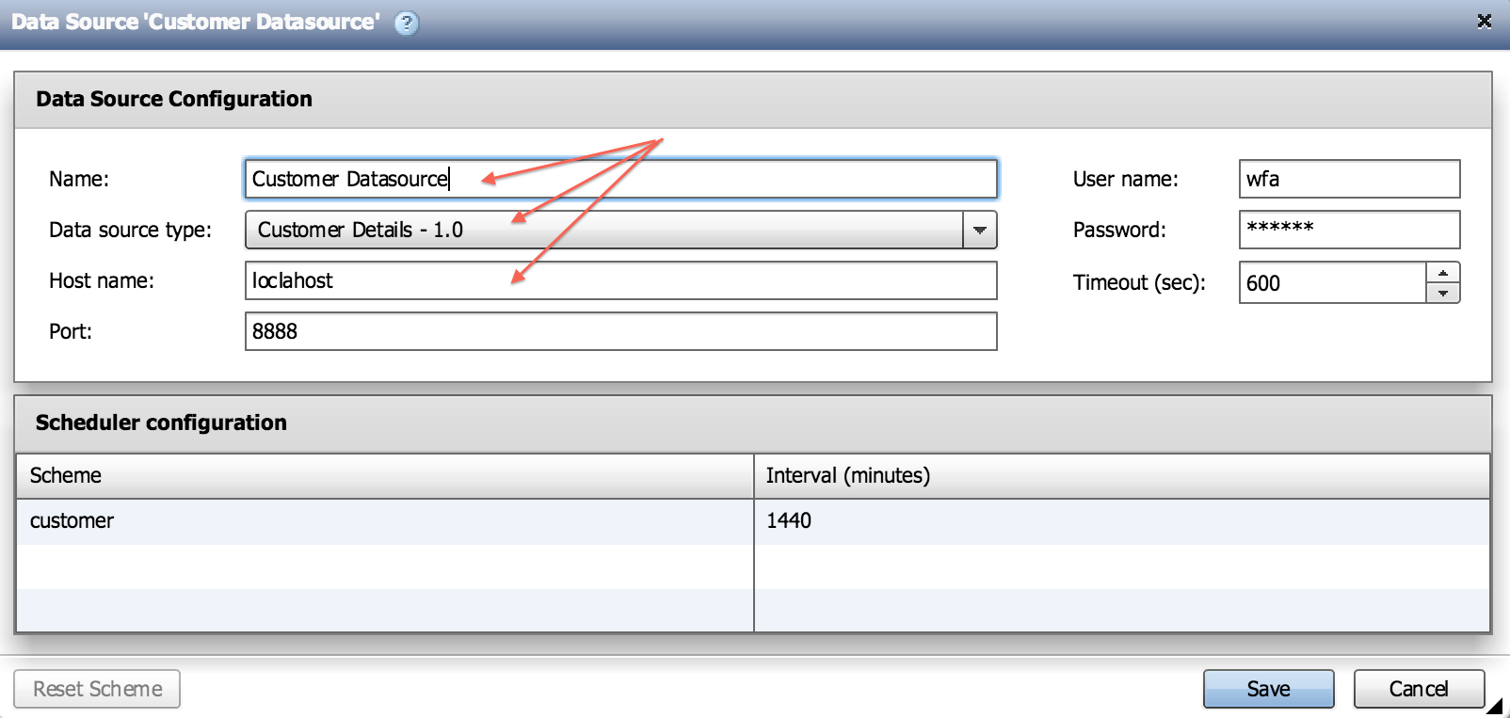
Reset the Schema
- WFA Portal > Designer Tab > Dictionary > Select ProtectionDetails > Reset Scheme
- WFA Portal > Designer Tab > Dictionary> Select PlatformDetails > Reset Scheme
Acquire Data
- WFA Portal > Execution Tab > Data Sources > Select “Customer Datasource”
- Right Click > Acquire Now

Update Existing Data source Types
Table 5) Update Existing Data Source Types - PlatformDetails and ProtectionDetails
Step | Action
 | WFA Portal > Data Source Types > Select Data Source > Edit Script
 | WFA Portal > Dictionary > Right Click > Reset Scheme
 | WFA Portal > Execution > Data Sources > Select Data Source > Acquire Now
- Resources

Execute the following commands, to learn the inbuilt cm_storage schema which requires connecting to WFA MySQL DB remotely using credentials wfa / Wfa123.
C:\Program Files\NetApp\WFA\mysql\my.conf
…
#bind-address=localhost

All resources can be downloaded from NetApp communities.
https://communities.netapp.com/message/117388#117388

