DWH logon DPR-GTY-5003 Error

- Remote Desktop into the DWH Server.

- Launch IBM Cognos Configuration manager – run as administrator to be safe
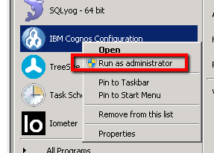
3) Change the following Setting
-- Environment->External JMX credential: no password (empty)
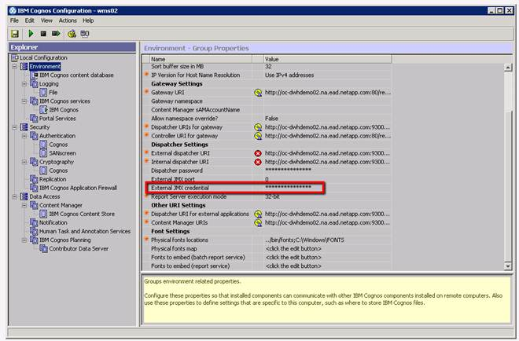
-- Environment->Portal Services->Shared secret: NoPassWordSet
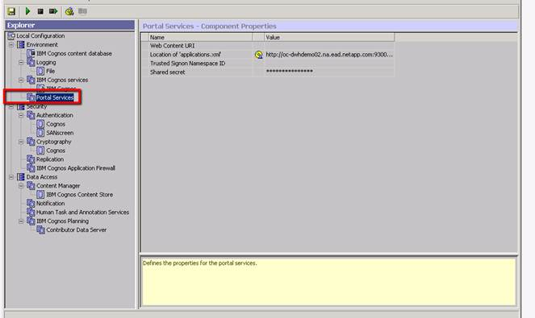
-- Data Access->Content manager->IBM Cognos Content Store->User ID and password: cognos/cognos
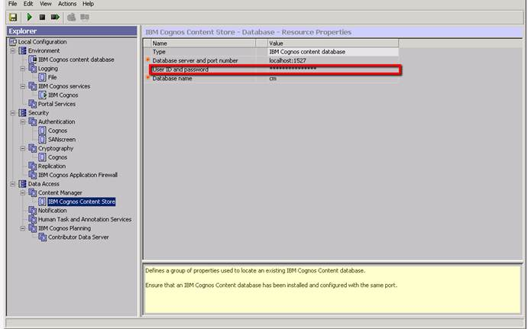
-- Data Access->Notification->Account and password: use the customer’s account information, or wipe it out completely if you don't know it
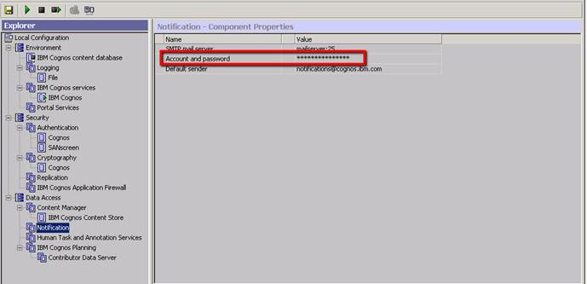

-- Security->Cryptography->Common symmetric key lifetime: change 365 days to 3650 days
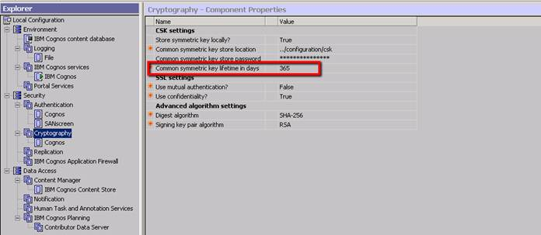

- Save the Cognos configuration - it may warn you that it is ingesting certs.
That is expected. This may take some time -you may see it talk
about regenerating crypto keys - that is what we need to do

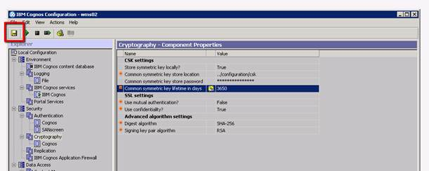

- When it is done,
In IBM Cognos Configuration, restart the Cognos Services. They should
come up clean
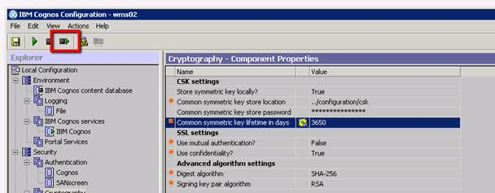

- When they are done, log into the Operational Server and restart the "SANscreen Server" service
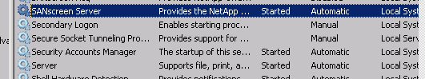

- When it is done, log in to dwh/reporting - you should be able to log
in, and see the Storage Manager dashboard

- log in to https://dwh/dwh as admin and perform a DWH backup with no performance - this WILL include the IBM Cognos Content store.
