The solution logic:
The logic is that a command executing on my WFA server can remotely connect to my windows desktop using the credentials provided by the workflow executor. Once connected, the WFA command reads the content of the file-path provided by the workflow-executor and gets it to the wfa server. Now my command has the contents of the file to make use of the way the workflow wants. The sample command here fetches that content and puts them in a file that is present on my WFA server.
One time setup for your Windows Desktop:
If your desktop is Linux, Ubuntu or Mac, this solution is not for you. The solution for all platforms is a bit different and will be provided later if required.
- Open “services.msc”
- Locate the service “Windows Remote Management (WS-Management)”
- Modify its Start-up Type to Automatic Delayed-start
- Start the service.
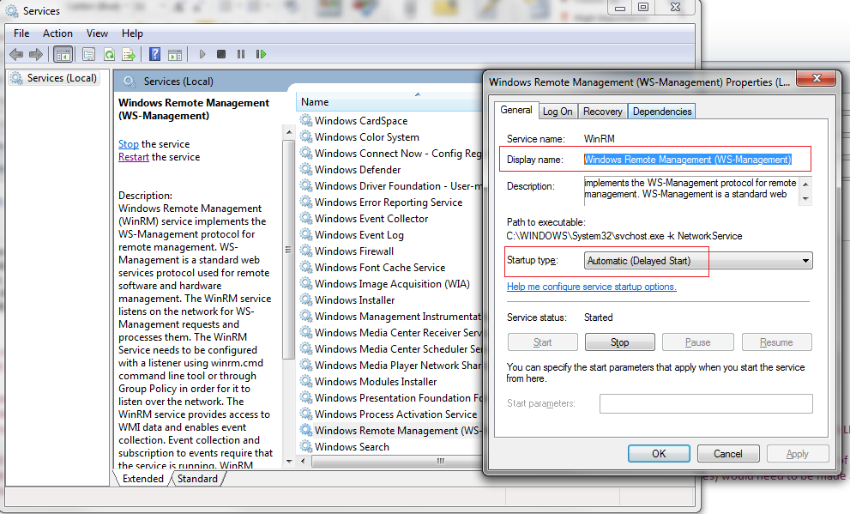
- Start Windows PowerShell as an administrator by right-clicking the Windows PowerShell shortcut and selecting Run As Administrator.
- Check service winrm is “Running”
- To configure Windows PowerShell for remoting, type the following command:
Enable-PSRemoting –force
- Add Trusted hosts for your WFA server. This is mostly an internal Windows machine so enable trusts to all.
winrm s winrm/config/client '@{TrustedHosts="*"}'

Else if you want to restrict remoting do the below
winrm s winrm/config/client '@{TrustedHosts="RemoteComputerIP1, RemoteComputerIP2"}'
- Now analyzes and configures the WinRM service using the below command.
winrm quickconfig
If you are prompted with any question, provide YES to all.

One time setup for your windows WFA server:
Same steps from (1) – (9) is needed. The idea is the WFA server should be able to invoke remote commands on your windows desktop.
After this, you are ready. All workflow executors are setup their own windows desktops for this.

Import the attached workflow. It’s a sample workflow. Provide the inputs something like below:
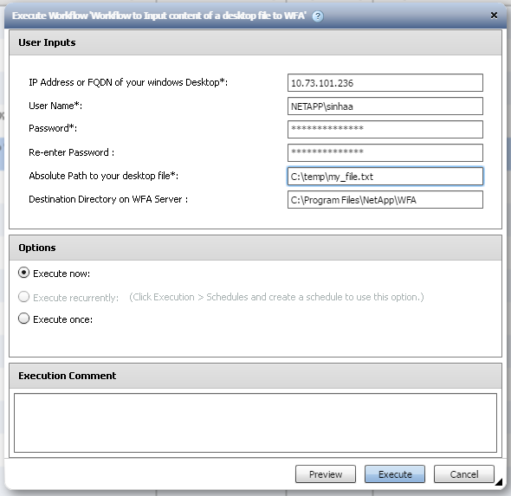

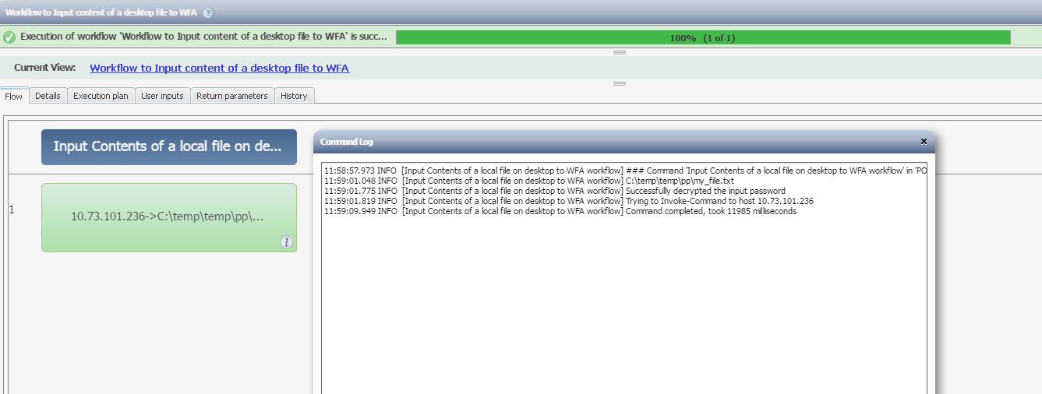

The file C:\temp\my_file.txt is present on my desktop. After executing the command, the contents of this file gets copied as C:\Program Files\NetApp\WFA\my_file.txt on my WFA server. Now the subsequent commands in the workflow can make use of this file as desired.

