Snapshots Requiring Clean-up
The reason why this process is required is due to the way SnapProtect and the DFM “work together”. Currently if a VM is deleted or moved to another volume and no other VM’s part of that same backup subclient exist on that volume the snapshots will not age and will require a manual clean-up process.
Finding a snapshot that has not aged.
Normally you will notice the snapshots on the volume are much older than the other vault copies that are continually updated as part of the SnapProtect subclients and DFM relationship.
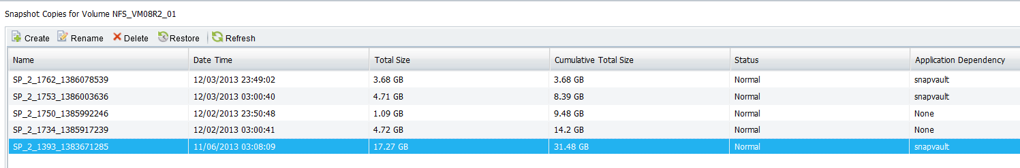
Locate the vault copy on the 2240.
Find the vaulted volume on the 2240, in this case the volume is NFS_VM08R2_01. If multiple vault copies have been created the 2240 will have created multiple volumes and will normally append _1, _2 or _3 and so on.
In this example we need to check for the correct volume that relates to the vault copy that needs to be removed from the dataset in DFM. We have 3 to choose from.
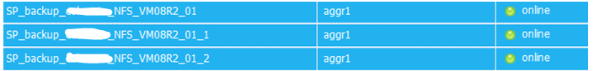
Checking the snapshots on these volumes I can see the one with only the vault relationship baseline snapshot. This is the one that has not been updated and needs to be removed in DFM.
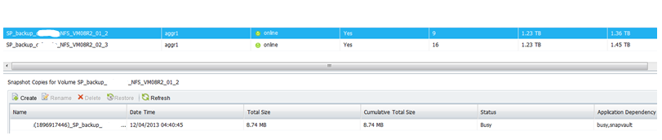
Locate the dataset in DFM that this vault relationship was created by.
Connect to DFM Server and open the DFM management console. Click on Data/Datasets and then click on the Provisioning tab. Click on each of the datasets looking for the volume name on the 2240. In this example we are looking for SP_backup_FILER_NFS_VM08R2_01_2.
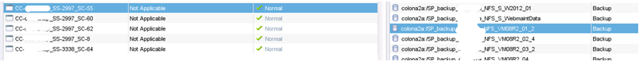

This vault relationship has been created by CC-SnapProtectServer_SS-2997_SC-55
No we need to remove the relationship from DFM
Open CMD on the DFM server
List the datasets to get the ID
C:\Users\TEMP>dfpm dataset list
Id Name Protection Policy Provisioning Policy Application Policy Storage Service
---------- --------------------------- --------------------------- ------------------- --------------------------- ---------------
3791 CC-SnapProtectServer_SS-14_SC-30 SnapProtect Back up CC-SnapProtectServer_SP-7_Copy-29
3860 CC-SnapProtectServer_SS-14_SC-48 SnapProtect Back up CC-SnapProtectServer_SP-7_Copy-29
3891 CC-SnapProtectServer_SS-14_SC-69 SnapProtect Back up CC-SnapProtectServer_SP-7_Copy-29
3912 CC-SnapProtectServer_SS-14_SC-70 SnapProtect Back up CC-SnapProtectServer_SP-7_Copy-29
3880 CC-SnapProtectServer_SS-15_SC-69 SnapProtect Back up CC-SnapProtectServer_SP-4_Copy-32
3260 CC-SnapProtectServer_SS-2997_SC-49 SnapProtect Back up CC-SnapProtectServer_SP-7_Copy-29
3293 CC-SnapProtectServer_SS-2997_SC-50 SnapProtect Back up CC-SnapProtectServer_SP-7_Copy-29
3092 CC-SnapProtectServer_SS-2997_SC-54 SnapProtect Back up CC-SnapProtectServer_SP-7_Copy-29
3179 CC-SnapProtectServer_SS-2997_SC-55 SnapProtect Back up CC-SnapProtectServer_SP-7_Copy-29
3150 CC-SnapProtectServer_SS-2997_SC-60 SnapProtect Back up CC-SnapProtectServer_SP-7_Copy-29
3247 CC-SnapProtectServer_SS-2997_SC-62 SnapProtect Back up CC-SnapProtectServer_SP-7_Copy-29
3026 CC-SnapProtectServer_SS-2997_SC-8 SnapProtect Back up CC-SnapProtectServer_SP-7_Copy-29
3341 CC-SnapProtectServer_SS-3338_SC-64 SnapProtect Back up CC-SnapProtectServer_SP-8_Copy-35

Get the ID of the dataset. In this example ID:3179
Now we need to get the vault relationship ID:3706
C:\Users\TEMP>dfpm dataset list -m 3179
Id Node Name Dataset Id Dataset Name Member Type Name
---------- -------------------- ---------- -------------------- -------------------------------------------------- -------------------------------------------------------
262 Primary data 3179 CC-SnapProtectServer_SS-2997_SC-55 qtree FILER:/NFS_VMGuest_03/-
287 Primary data 3179 CC-SnapProtectServer_SS-2997_SC-55 qtree FILER:/NFS_VMGuest_04/-
597 Primary data 3179 CC-SnapProtectServer_SS-2997_SC-55 qtree FILER2:/NFSB_VM2k3_05/-
598 Primary data 3179 CC-SnapProtectServer_SS-2997_SC-55 qtree FILER2:/NFSB_VM08R2_05/-
1995 Primary data 3179 CC-SnapProtectServer_SS-2997_SC-55 qtree FILER:/NFS_S_SCCM_01/-
2280 Primary data 3179 CC-SnapProtectServer_SS-2997_SC-55 qtree FILER2:/NFS_G_W2012_02/-
2285 Primary data 3179 CC-SnapProtectServer_SS-2997_SC-55 qtree FILER2:/NFS_G_W2008R2_02/-
2286 Primary data 3179 CC-SnapProtectServer_SS-2997_SC-55 qtree FILER2:/NFS_G_W2012_04/-
2290 Primary data 3179 CC-SnapProtectServer_SS-2997_SC-55 qtree FILER2:/NFS_G_W2008R2_03/-
2308 Primary data 3179 CC-SnapProtectServer_SS-2997_SC-55 qtree FILER:/NFS_S_W2008R2_02/-
2310 Primary data 3179 CC-SnapProtectServer_SS-2997_SC-55 qtree FILER:/NFS_S_W2008R2_03/-
2312 Primary data 3179 CC-SnapProtectServer_SS-2997_SC-55 qtree FILER:/NFS_S_W2008R2_01/-
2313 Primary data 3179 CC-SnapProtectServer_SS-2997_SC-55 qtree FILER:/NFS_S_W2012_01/-
2557 Primary data 3179 CC-SnapProtectServer_SS-2997_SC-55 qtree FILER:/NFS_S_Redirects/-
3746 Primary data 3179 CC-SnapProtectServer_SS-2997_SC-55 qtree FILER:/NFS_S_WebmaintData/-
298 Primary data 3179 CC-SnapProtectServer_SS-2997_SC-55 qtree FILER:/NFS_VMGuest_05/-
299 Primary data 3179 CC-SnapProtectServer_SS-2997_SC-55 qtree FILER:/NFS_VMGuest_06/-
507 Primary data 3179 CC-SnapProtectServer_SS-2997_SC-55 qtree FILER:/NFS_VM2k3_01/-
518 Primary data 3179 CC-SnapProtectServer_SS-2997_SC-55 qtree FILER:/NFS_VM2k3_03/-
519 Primary data 3179 CC-SnapProtectServer_SS-2997_SC-55 qtree FILER:/NFS_VM2k8_01/-
521 Primary data 3179 CC-SnapProtectServer_SS-2997_SC-55 qtree FILER:/NFS_VM08R2_01/-
524 Primary data 3179 CC-SnapProtectServer_SS-2997_SC-55 qtree FILER:/NFS_VM08R2_02/-
529 Primary data 3179 CC-SnapProtectServer_SS-2997_SC-55 qtree FILER:/NFS_VM08R2_03/-
530 Primary data 3179 CC-SnapProtectServer_SS-2997_SC-55 qtree FILER:/NFS_VM08R2_04/-
567 Primary data 3179 CC-SnapProtectServer_SS-2997_SC-55 qtree FILER:/NFS_VMNix_01/-
883 Primary data 3179 CC-SnapProtectServer_SS-2997_SC-55 qtree FILER2:/NFSB_VM08R2_06/-
885 Primary data 3179 CC-SnapProtectServer_SS-2997_SC-55 qtree FILER2:/NFSB_VM08R2_07/-
2128 Primary data 3179 CC-SnapProtectServer_SS-2997_SC-55 qtree FILER2:/NFS_G_RPT01DATA/-
2231 Primary data 3179 CC-SnapProtectServer_SS-2997_SC-55 qtree FILER:/NFS_S_W2003_03/-
2234 Primary data 3179 CC-SnapProtectServer_SS-2997_SC-55 qtree FILER:/NFS_S_W2008_02/-
2274 Primary data 3179 CC-SnapProtectServer_SS-2997_SC-55 qtree FILER2:/NFS_G_W2008R2_01/-
2275 Primary data 3179 CC-SnapProtectServer_SS-2997_SC-55 qtree FILER2:/NFS_G_W2008R2_04/-
2358 Primary data 3179 CC-SnapProtectServer_SS-2997_SC-55 qtree FILER2:/NFS_G_WebData_03/-
2359 Primary data 3179 CC-SnapProtectServer_SS-2997_SC-55 qtree FILER2:/NFS_G_WebData_01/-
2360 Primary data 3179 CC-SnapProtectServer_SS-2997_SC-55 qtree FILER2:/NFS_G_WebData_02/-
2363 Primary data 3179 CC-SnapProtectServer_SS-2997_SC-55 qtree FILER2:/NFS_G_VCENTER_DATA/-
2366 Primary data 3179 CC-SnapProtectServer_SS-2997_SC-55 qtree FILER:/NFS_S_TEMPLATES/-
2369 Primary data 3179 CC-SnapProtectServer_SS-2997_SC-55 qtree FILER:/NFS_S_TREND_DATA/-
2374 Primary data 3179 CC-SnapProtectServer_SS-2997_SC-55 qtree FILER2:/NFS_G_NIX_01/-
2375 Primary data 3179 CC-SnapProtectServer_SS-2997_SC-55 qtree FILER2:/NFS_G_NIX_02/-
2380 Primary data 3179 CC-SnapProtectServer_SS-2997_SC-55 qtree FILER:/NFS_S_NIX_02/-
2381 Primary data 3179 CC-SnapProtectServer_SS-2997_SC-55 qtree FILER:/NFS_S_NIX_01/-
3180 Backup 3179 CC-SnapProtectServer_SS-2997_SC-55 volume Filer2240:/SP_backup_FILER2_NFS_G_W2008R2_03
3183 Backup 3179 CC-SnapProtectServer_SS-2997_SC-55 volume Filer2240:/SP_backup_FILER2_NFS_G_WebData_01
3186 Backup 3179 CC-SnapProtectServer_SS-2997_SC-55 volume Filer2240:/SP_backup_FILER2_NFS_G_WebData_02
3395 Backup 3179 CC-SnapProtectServer_SS-2997_SC-55 volume Filer2240:/SP_backup_FILER_NFS_VM08R2_03_2
3398 Backup 3179 CC-SnapProtectServer_SS-2997_SC-55 volume Filer2240:/SP_backup_FILER_NFS_S_NIX_02
3401 Backup 3179 CC-SnapProtectServer_SS-2997_SC-55 volume Filer2240:/SP_backup_FILER_NFS_S_W2008R2_01
3404 Backup 3179 CC-SnapProtectServer_SS-2997_SC-55 volume Filer2240:/SP_backup_FILER_NFS_VM2k3_03_1
3409 Backup 3179 CC-SnapProtectServer_SS-2997_SC-55 volume Filer2240:/SP_backup_FILER_NFS_VMGuest_06_2
3505 Backup 3179 CC-SnapProtectServer_SS-2997_SC-55 volume Filer2240:/SP_backup_FILER2_NFS_G_W2012_04
3508 Backup 3179 CC-SnapProtectServer_SS-2997_SC-55 volume Filer2240:/SP_backup_FILER2_NFS_G_W2012_02
3511 Backup 3179 CC-SnapProtectServer_SS-2997_SC-55 volume Filer2240:/SP_backup_FILER2_NFS_G_RPT01DATA
3514 Backup 3179 CC-SnapProtectServer_SS-2997_SC-55 volume Filer2240:/SP_backup_FILER_NFS_VM08R2_02_4
3517 Backup 3179 CC-SnapProtectServer_SS-2997_SC-55 volume Filer2240:/SP_backup_FILER_NFS_VM2k8_01_1
3520 Backup 3179 CC-SnapProtectServer_SS-2997_SC-55 volume Filer2240:/SP_backup_FILER_NFS_S_TREND_DATA
3523 Backup 3179 CC-SnapProtectServer_SS-2997_SC-55 volume Filer2240:/SP_backup_FILER_NFS_VMGuest_04_2
3389 Backup 3179 CC-SnapProtectServer_SS-2997_SC-55 volume Filer2240:/SP_backup_FILER2_NFSB_VM08R2_06
3392 Backup 3179 CC-SnapProtectServer_SS-2997_SC-55 volume Filer2240:/SP_backup_FILER2_NFSB_VM2k3_05
3526 Backup 3179 CC-SnapProtectServer_SS-2997_SC-55 volume Filer2240:/SP_backup_FILER_NFS_S_W2012_01
3225 Backup 3179 CC-SnapProtectServer_SS-2997_SC-55 volume Filer2240:/SP_backup_FILER_NFS_S_W2008_02
3228 Backup 3179 CC-SnapProtectServer_SS-2997_SC-55 volume Filer2240:/SP_backup_FILER2_NFSB_VM08R2_05
3231 Backup 3179 CC-SnapProtectServer_SS-2997_SC-55 volume Filer2240:/SP_backup_FILER2_NFS_G_NIX_01
3234 Backup 3179 CC-SnapProtectServer_SS-2997_SC-55 volume Filer2240:/SP_backup_FILER2_NFS_G_NIX_02
3261 Backup 3179 CC-SnapProtectServer_SS-2997_SC-55 volume Filer2240:/SP_backup_FILER2_NFS_G_W2008R2_01
3264 Backup 3179 CC-SnapProtectServer_SS-2997_SC-55 volume Filer2240:/SP_backup_FILER_NFS_VM08R2_04
3267 Backup 3179 CC-SnapProtectServer_SS-2997_SC-55 volume Filer2240:/SP_backup_FILER_NFS_VMGuest_03_2
3579 Backup 3179 CC-SnapProtectServer_SS-2997_SC-55 volume Filer2240:/SP_backup_FILER_NFS_VMGuest_05_1
3582 Backup 3179 CC-SnapProtectServer_SS-2997_SC-55 volume Filer2240:/SP_backup_FILER_NFS_S_W2008R2_02_3
3585 Backup 3179 CC-SnapProtectServer_SS-2997_SC-55 volume Filer2240:/SP_backup_FILER_NFS_S_W2008R2_03_1
3588 Backup 3179 CC-SnapProtectServer_SS-2997_SC-55 volume Filer2240:/SP_backup_FILER_NFS_VMNix_01
3591 Backup 3179 CC-SnapProtectServer_SS-2997_SC-55 volume Filer2240:/SP_backup_FILER_NFS_S_Redirects
3676 Backup 3179 CC-SnapProtectServer_SS-2997_SC-55 volume Filer2240:/SP_backup_FILER_NFS_VM08R2_01_2
3683 Backup 3179 CC-SnapProtectServer_SS-2997_SC-55 volume Filer2240:/SP_backup_FILER2_NFS_G_VCENTER_DATA
3686 Backup 3179 CC-SnapProtectServer_SS-2997_SC-55 volume Filer2240:/SP_backup_FILER2_NFS_G_WebData_03_1
3689 Backup 3179 CC-SnapProtectServer_SS-2997_SC-55 volume Filer2240:/SP_backup_FILER2_NFS_G_W2008R2_04_1
3692 Backup 3179 CC-SnapProtectServer_SS-2997_SC-55 volume Filer2240:/SP_backup_FILER2_NFS_G_W2008R2_02_1
3734 Backup 3179 CC-SnapProtectServer_SS-2997_SC-55 volume Filer2240:/SP_backup_FILER_NFS_S_W2003_03
3763 Backup 3179 CC-SnapProtectServer_SS-2997_SC-55 volume Filer2240:/SP_backup_FILER_NFS_S_SCCM_01
3766 Backup 3179 CC-SnapProtectServer_SS-2997_SC-55 volume Filer2240:/SP_backup_FILER_NFS_VM2k3_01_1
3769 Backup 3179 CC-SnapProtectServer_SS-2997_SC-55 volume Filer2240:/SP_backup_FILER_NFS_S_NIX_01_1
3772 Backup 3179 CC-SnapProtectServer_SS-2997_SC-55 volume Filer2240:/SP_backup_FILER_NFS_S_TEMPLATES
3775 Backup 3179 CC-SnapProtectServer_SS-2997_SC-55 volume Filer2240:/SP_backup_FILER2_NFSB_VM08R2_07_1
3826 Backup 3179 CC-SnapProtectServer_SS-2997_SC-55 volume Filer2240:/SP_backup_FILER_NFS_S_WebmaintData

C:\Users\TEMP>dfpm dataset relinquish 3676
Relinquished relationship (3680) with destination SP_FILER_NFS_VM08R2_01 (3679).

Now click back on the Data/Dataset/Overview from the DMF console
Right click and Edit the dataset: in this example CC-SnapProtectServer_SS-2997_SC-55
Remove the volume from the primary physical resource and the secondary physical resource

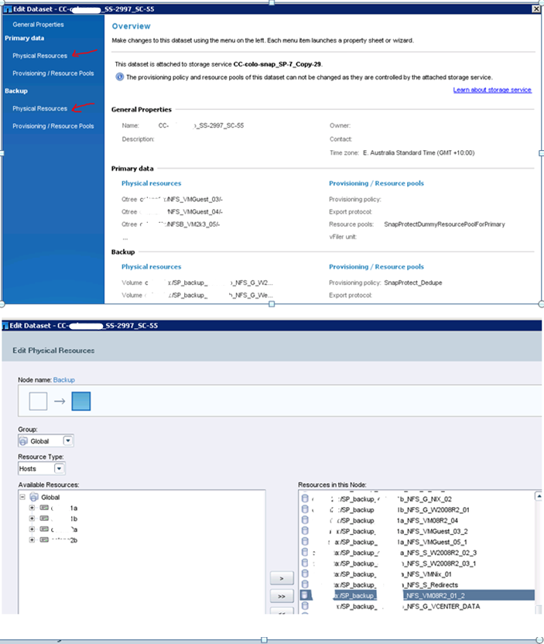
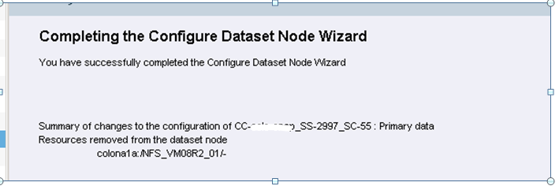
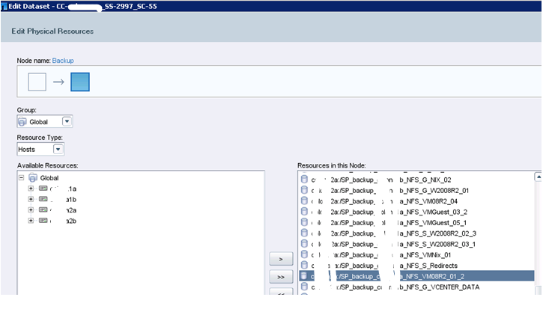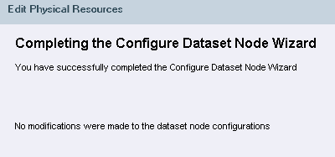

Clean-up to the filer
Secondary filer:
Snapvault status

Copy the full name

Filer2240:/vol/SP_backup_FILER_ NFS_VM08R2_01/ SP_FILER_NFS_VM08R2_01

snapvault stop Filer2240:/vol/SP_backup_FILER_ NFS_VM08R2_01/ SP_FILER_NFS_VM08R2_01

Primary
FILER2> snap list NFS_VM08R2_01
snap delete “Volume name” space “snapshot name”
snap delete NFS_VM08R2_01 SP_2_1393_1383671285

FILER2> snap list NFS_VM08R2_01

Connect to SnapProtect Server
Open the SnapProtect console
Click on Storage at the top menu and select Array Management
Click on the main filer and click list snaps
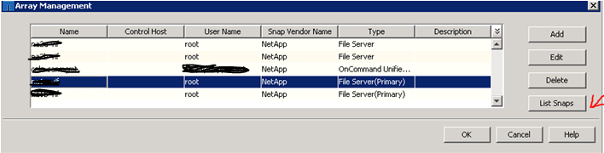
From the Array Management hopefully you will see the job number. This can be found on the primary snapshot Example: SP_2_1393_1383671285

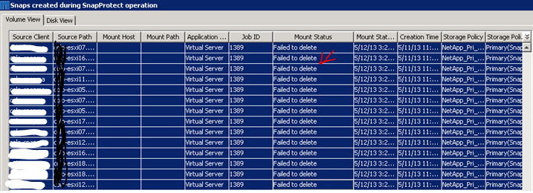

No that the vault relationship has been removed the old snapshots can be highlighted and deleted. This will clean the rest of the snapshots spread across the other volumes.

Once the volume on the 2240 has no more snapshots and the space utilized is 0% the vaulted volume on the 2240 can be taken offline and deleted.

