Customer SQL and SharePoint
Provisioning Procedures

Version 1.0

Status: Draft

TABLE OF CONTENTS
1 Application 3
1.1 SnapDrive for Windows 6.3 LUNs 3
1.2 SnapDrive for Windows 6.3 RDM LUNs 10
1.3 SnapManager 5.2 for SQL 11
1.4 SnapManager 6.1 for SharePoint 14

LIST OF TABLES
Table 1) Backup job scheduling template. 19
Table 2) SMSP Media Service configuration prerequisites. 25
Table 3) Information for configuring data devices. 27
Table 4) Information for configuring the other archived data devices. 29

LIST OF FIGURES
No table of figures entries found.

Application

SnapDrive for Windows 6.3 LUNs

Create a Dedicated LUN
Complete the following steps to create a dedicated LUN:
- Launch the Create Disk Wizard:
  - Select the SnapDrive instance for which to create a disk.
  - Select Disks.
  - From the menu choices at the top of MMC, navigate to Action > Create Disk.
  - The Create Disk Wizard will launch.
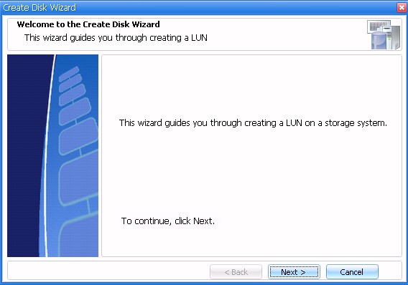
- In the Create Disk Wizard, click Next. The Provide Storage System Name, LUN Path, and Name panel will display.
- In the Provide a Storage System Name, LUN Path, and LUN Name panel fields, enter the following:
  - In the Storage System Name field, type the storage system name where the LUN will be created, or select an existing storage system using the pull-down menu.
  - In the LUN Path field, type the LUN path or select the path on the storage system added in Step a.
  - In the LUN Name field, enter a name for the LUN, and click Next. The Select a LUN Type panel will display.
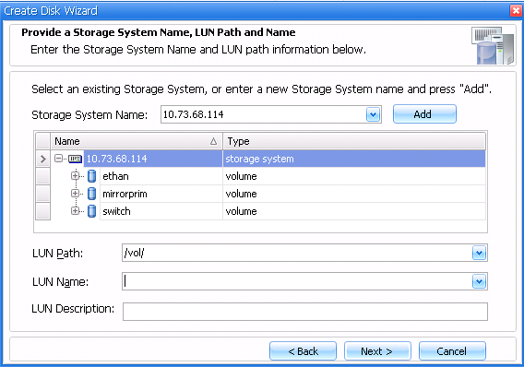
- In the Select a LUN Type panel, select Dedicated, and then click Next.
- In the Select LUN Properties panel, select a drive letter from the list of available drive letters or type a volume mount point for the LUN that will be created. To create a volume mount point, type the drive path that the mounted drive will use. Example: G:\mount_drive1\
- While still in the Select LUN Properties panel, complete the following actions:
  - For the option labeled “Do you want to limit the maximum disk size to accommodate at least one snapshot?” click Limit (default) or Do Not Limit. For the Limit option, the disk size limits that display are accurate only when they first appear on the Select LUN Properties panel. When this option is selected, the following actions might interfere with creating at least one Snapshot copy:
- The option is changed to Do Not Limit and SnapDrive is used to create an additional LUN in the same storage system volume.
- A LUN is created in the same storage system volume without using SnapDrive.
- Data objects other than LUNs are stored on this storage system volume.
  - Select a LUN size that falls within the minimum and maximum values displayed in the panel.
  - Click Next.
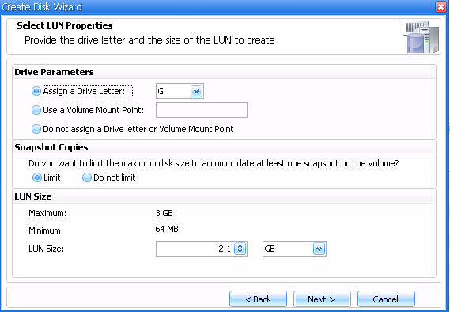
If the settings on the storage system volume or qtree on which the LUN will be created do not allow SnapDrive to proceed with the create operation, the Important Properties of the Storage System Volume panel displays, as described in Step
Error! Reference source not found.. Otherwise, proceed to Step
Error! Reference source not found..
- The Important Properties of the Storage System Volume panel displays the settings that are used for the volume or qtree specified earlier in this procedure. SnapDrive requires that the storage system volume containing LUNs have the following properties:
  - create_ucode = On
  - convert_ucode = On
  - snapshot_schedule = Off
SnapDrive cannot create a LUN unless the settings shown above are configured.
While the create_ucode and convert_ucode volume options are no longer used, they are set to maintain backwards compatibility with older versions of SnapDrive.
  - Click Next, the Select Initiators panel will display.
- In the Initiator List pane, select an initiator for the LUN that will be created.
If an iSCSI initiator is selected, and an iSCSI connection to the storage system on which the LUN being created does not exist, SnapDrive launches the Create iSCSI Session Wizard and prompts the user to select a target portal and initiator. Also, the target requires authentication of hosts that connect to it, the authentication information can be entered here. Click OK; the iSCSI connection from the Windows host to the storage system will then be established, even if the Create Disk Wizard does not complete. If MPIO is installed and iSCSI and FC are used, an iSCSI initiator and several FC initiators can be selected.
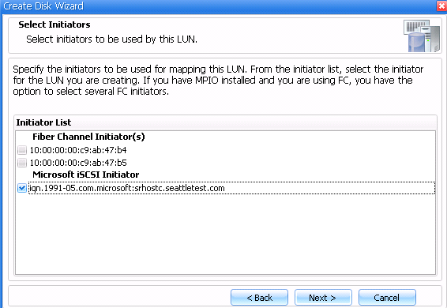
- Click Next, the Select Initiator Group Management panel will display.
- From the Select Initiator Group Management panel, specify whether to use automatic or manual igroup management. For automatic igroup management, SnapDrive uses existing igroups, or, when necessary, creates new igroups for the initiator specified in Step
Error! Reference source not found.. For manual igroup management, manually choose existing igroups or create new ones as needed.
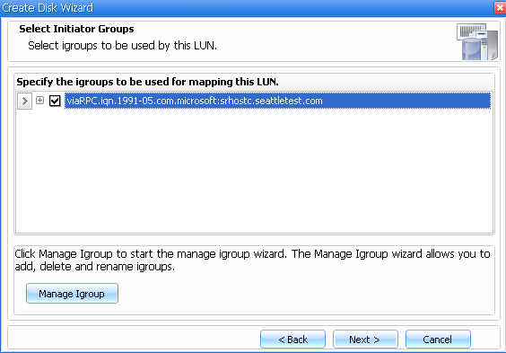
- From the Completing the Create Disk Wizard panel, complete the following steps:
- Verify the settings. To change a setting, click Back to go back to the previous wizard panels.
- Click Finish.
This process may take several seconds to complete. SnapDrive displays the disk creation status in the lower center panel of the MMC pane.

Create a Shared LUN
Use SnapDrive to create FC- or iSCSI-accessed LUNs that are shared between clustered Windows servers.
Complete the following steps to create a shared LUN:
- Perform the following actions to launch the Create Disk Wizard:
  - Select the SnapDrive instance for which to create a disk.
  - Select Disks.
  - From the menu choices at the top of MMC, navigate to Action > Create Disk.
  - The Create Disk Wizard is launched.
- From the Create Disk Wizard, click Next. The Provide Storage System Name, LUN Path, and LUN Name panel displays.
- In the Provide a Storage System Name, LUN Path, and LUN Name panel, perform the following:
  - In the Storage System Name field, type the storage system name where the LUN will be created or select an existing storage system using the pull-down menu.
  - In the LUN Path field, type the LUN path or select the path on the storage system added in Step a.
  - In the LUN Name field, enter a name for the LUN and click Next. The select a LUN Type panel is displayed.
- In the Select a LUN Type panel, select Shared, and then click Next.
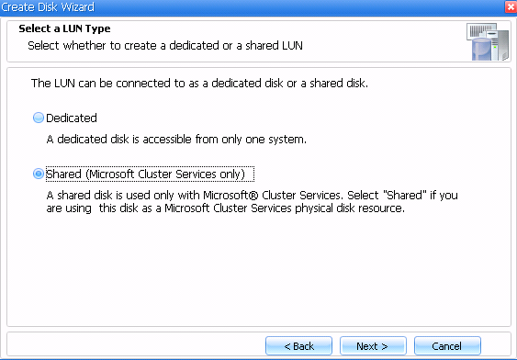
- In the Information About the Microsoft Cluster Services System panel, select Shared to share the disk with the listed nodes, and then click Next. The Specify Microsoft Cluster Services Group panel displays.
- In the Specify Microsoft Cluster Services Group panel, perform one of the following, and then click Next.
  - Select a cluster group from the Group Name drop-down list.
When selecting a cluster group for the LUNs, choose one that the application uses. When creating a volume mount point, the cluster group is already selected because the cluster group owns the root volume physical disk cluster resources. NetApp recommends creating new shared LUNs outside of the cluster group.
  - Select Create a New Cluster Group to create a new cluster group.
  - Select Add to cluster shared volumes.
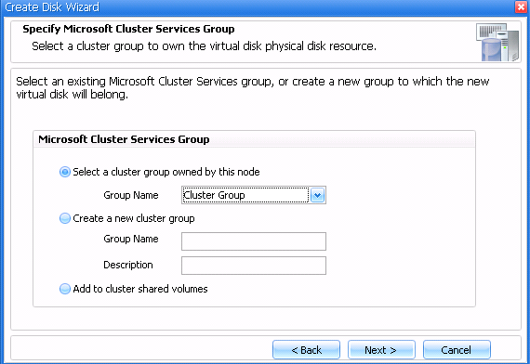
- In the Select LUN Properties panel, either select a drive letter from the list of available drive letters or enter a volume mount point for the LUN that will be created. When creating a volume mount point, enter the drive path that the mounted drive will use. For example, G:\mount_drive1\.
The volume mount point root must be owned by the node on which the new disk is being created.
Cascading volume mount points (one mount point mounted on another mount point) can be created; however, in the case of a cascading mount point created on an MSCS shared disk, a system event warning might be sent indicating that disk dependencies might not be correctly set. This is not the case; however, as SnapDrive will create the dependencies and the mounted disks will function as expected.
- While still in the Select LUN Properties panel, complete the following actions:
  - For the option labeled “Do you want to limit the maximum disk size to accommodate at least one snapshot?” click Limit (default) or Do Not Limit. For the Limit option, the disk size limits that display are accurate only when they first appear on the Select LUN Properties panel. When this option is selected, the following actions might interfere with creating at least one Snapshot copy:
- The option is changed to Do Not Limit and SnapDrive is used to create an additional LUN in the same storage system volume.
- A LUN is created in the same storage system volume without using SnapDrive.
- Data objects other than LUNs are stored on this storage system volume.
  - Select a LUN size. The size must fall within the minimum and maximum values displayed in the panel.
  - Click Next.
If the settings on the storage system volume or qtree on which the LUN is being created do not allow SnapDrive to proceed with the create operation, the Important Properties of the Storage System Volume panel displays, as described in Step
9. Otherwise, proceed to Step
10.
- The Important Properties of the Storage System Volume panel displays the settings that are used for the volume or qtree specified earlier in this procedure. SnapDrive requires that the storage system volume containing LUNs have the following properties:
  - create_ucode = On
  - convert_ucode = On
  - snapshot_schedule = Off
SnapDrive cannot create a LUN unless the settings shown above are configured.
While the create_ucode and convert_ucode volume options are no longer used, they are set to maintain backwards compatibility with older versions of SnapDrive.
  - Click Next, the Select Initiators panel will display.
- In the Select Initiators panel, perform the following actions:
  - Double-click the cluster group name in order to display the hosts that belong to that cluster.
  - Click the name of a host. The available initiators for that host will display in the Initiator List located in the lower portion of the pane.
- In the Initiator List pane, select an initiator for the LUN that will be created.
If an iSCSI initiator is selected, and an iSCSI connection to the storage system on which the LUN being created does not exist, SnapDrive launches the Create iSCSI Session Wizard and prompts the user to select a target portal and initiator. Also, the target requires authentication of hosts that connect to it, the authentication information can be entered here. Click OK; the iSCSI connection from the Windows host to the storage system will then be established, even if the Create Disk Wizard does not complete. If MPIO is installed and iSCSI and FC are used, an iSCSI initiator and several FC initiators can be selected.
- Repeat Steps
10 and
11 for all hosts, and then click Next. The Select Initiator Group Management panel will display.
The Next button remains inactive until initiators for all hosts of a cluster are selected.
- In the Select Initiator Group Management panel, specify automatic or manual igroup management. For automatic igroup management, SnapDrive uses existing igroups, or, when necessary, creates new igroups for the initiators specified in Steps
10 through
12. For manual igroup management, manually choose existing igroups or create new ones as needed.
- In the Completing the Create Disk Wizard panel, perform the following actions:
- Verify the settings. To change a setting, click Back to go back to the previous wizard panels.
- Click Finish.
This process can take several seconds to complete. SnapDrive displays the disk creation status in the lower center panel of the MMC pane.

Configure a Windows Server 2008 Failover Cluster Witness Disk
SnapDrive for Windows and Windows Server 2008 provides a simpler way of configuring a shared disk as a witness disk than in earlier versions of SnapDrive and Windows Server. While SnapDrive still supports the previous method of configuring a quorum, it is no longer necessary to create a shared disk before creating a cluster, nor is it necessary to connect that shared disk to the node before that node can be added to the cluster.
Complete the following steps to configure a Windows Server 2008 failover cluster witness disk:
- Navigate to Start > Administrative Tools > Failover Cluster Management to launch the Windows Server 2008 Failover Cluster Management snap-in.
- Click the name of the failover cluster for which to configure the witness disk.
- From the menu choices at the top of the snap-in, navigate to Action > More Actions > Configure Cluster Quorum Settings. The Configure Cluster Quorum Wizard will launch.
- In the Configure Cluster Quorum Wizard, click Next. The Select Quorum Configuration panel will display.
- In the Select Quorum Configuration panel, select Node and Disk Majority, and then click Next. The Configure Storage Witness panel will display.
- In the Configure Storage Witness panel, select the shared LUN that was created as the witness disk in SnapDrive, and then click Next. The Confirmation panel will display.
- In the Confirmation panel, click Next to configure the Cluster Quorum settings. After the quorum settings are configured, the Summary panel will display.
- In the Summary panel, click Finish to close the wizard.

SnapDrive for Windows 6.3 RDM LUNs

Create RDM LUN on Guest OS
Complete the following steps to create FC, iSCSI, or ESX iSCSI accessed RDM LUNs on a guest OS:
- Launch the Create Disk Wizard:
  - Log on to the guest VM. Select the SnapDrive instance for which to create a disk.
  - Select Disks.
  - From the menu choices at the top of MMC, navigate to Action > Create Disk.
  - The Create Disk Wizard will launch.
- In the Create Disk Wizard, click Next. The Provide Storage System Name, LUN Path, and Name panel will display.
- In the Provide a Storage System Name, LUN Path, and LUN Name fields, enter the following information:
  - In the Storage System Name field, type the storage system name where the LUN will be created or select an existing storage system using the pull-down menu.
  - In the LUN Path field, type the LUN path or select the path of the storage system added in Step a.
  - In the LUN Name field, enter a name for the LUN, and then click Next. The Select a LUN Type panel will display.
- In the Select a LUN Type panel, select Dedicated, and then click Next.
- In the Select LUN Properties panel, either select a drive letter from the list of available drive letters or enter a volume mount point for the LUN being creating. To create a volume mount point, enter the drive path that the mounted drive will use. For example, G:\mount_drive1\.
The volume mount point root must be owned by the node on which the new disk is being created.
- While still in the Select LUN Properties panel, complete the following actions:
  - For the option labeled “Do you want to limit the maximum disk size to accommodate at least one snapshot?” click Limit (default) or Do Not Limit. If you select Limit, the disk size limits that display are accurate only when they first appear on the Select LUN Properties panel. When this option is selected, the following actions might interfere with the creation of at least one Snapshot copy:
- The option is changed to Do Not Limit and SnapDrive is used to create an additional LUN in the same storage system volume.
- A LUN is created in the same storage system volume without using SnapDrive
- Data objects other than LUNs are stored on this storage system volume.
  - Select a LUN size. The size must fall within the minimum and maximum values displayed in the panel.
  - Click Next.
If the settings on the storage system volume or qtree on which the LUN is being created do not allow SnapDrive to proceed with the create operation, the Important Properties of the Storage System Volume panel displays, as described in Step Otherwise, proceed to Step
Error! Reference source not found..
- The Important Properties of the Storage System Volume panel displays the settings that are used for the volume or qtree specified earlier in this procedure. SnapDrive requires that the storage system volume containing LUNs have the following properties:
  - create_ucode = On
  - convert_ucode = On
  - snapshot_schedule = Off
SnapDrive cannot create a LUN unless the settings shown above are configured.
While the create_ucode and convert_ucode volume options are no longer used, they are set to maintain backwards compatibility with older versions of SnapDrive.
  - Click Next, the Select Initiators panel will display.
- In the Initiator List pane, select an initiator for the LUN being created. If MPIO is installed, several FC initiators can be selected.
Do not select both iSCSI and FC initiators when creating a LUN on a guest OS.
- Click Next, the Select Initiator Group Management panel will display.
- In the Select Initiator Group Management panel, specify automatic or manual igroup management. For automatic igroup management, SnapDrive uses existing igroups, or, when necessary, creates new igroups for the initiators specified. For manual igroup management, manually choose existing igroups or create new ones as needed.
For automatic igroup, SnapDrive will only add the current ESX host into the new igroup. When you then try to do a VMotion it will fail because the other ESX nodes in the ESX cluster cannot access the LUN.
To create manual igroups and work with protection manager integration, create that igroup on the secondary storage, otherwise, Verify on Secondary Storage might fail.
- In the Select a Datastore panel, complete the following steps.
  - If the VM resides on a VMFS datastore, choose either Store with Virtual Machine (default), or choose Specify Datastore to select a different VMFS datastore for the VMDK file to reside. Click Next.
  - If the VM resides on an NFS datastore, choose Specify Datastore to select a different VMFS datastore for the VMDK file to reside. Click Next.
The Store with Virtual Machine option is not available because a VMDK file cannot be stored on an NFS datastore.
- In the Completing the Create Disk wizard panel, perform the following:
- Verify the settings. To change a setting, click Back to go back to the previous wizard panels.
- Click Finish.
This process can take several seconds to complete. SnapDrive displays the disk creation status in the lower center panel of the MMC pane.

SnapManager 5.2 for SQL

Configure Monitoring and Reporting Operations
SMSQL 5.2 is required for this procedure. To configure monitoring and reporting operations, complete the following steps:
- Start the SMSQL 5.2 Configuration wizard. During this database configuration process, the Configure Monitoring and Reporting Settings page appears.
  - Select Enable Monitoring and Reporting.
  - Select the options for backup, verification, and clone resync.
  - Select a reporting interval.
  - Select a time for the report operations to start.
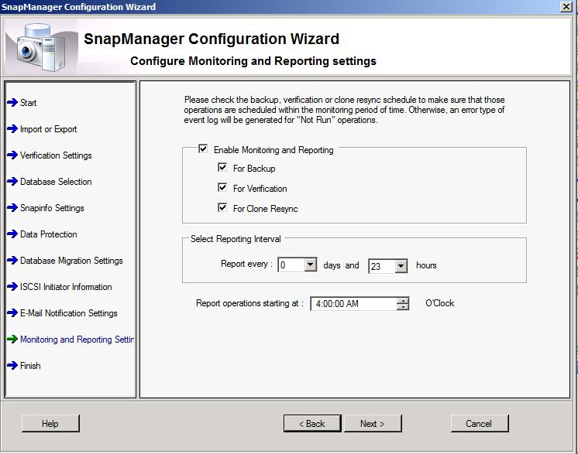
- Click Next and click Finish.

Move Report Directory Settings to Different Location
SMSQL 5.2 is required for performing this procedure on SQL Server 2008 and 2008 R2.
By default, the settings for the SMSQL 5.2 report directory are stored in the same location where SMSQL 5.2 is installed.

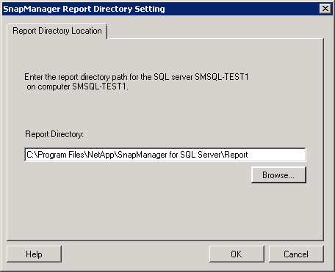
The location of the SMSQL 5.2 report directory can be changed for various reasons:
- Limited space. If disk space is limited in the current report directory, the report directory can be moved to a different location that has more disk space available.
- Clustered environment. If Microsoft SQL Server is running on a MSCS cluster, storing the SMSQL 5.2 reports in the default location (a directory named Report under the SMSQL 5.2 installation directory) does not allow the report directory to be shared between the nodes in the cluster. Additionally, the reports are not visible from different nodes.
To avoid these problems, the report directory can be moved to a disk that belongs to the same group as the Microsoft SQL Server. This operation must be performed from every SMSQL 5.2 node.
To change the report directory settings, complete the following steps:
- Select SMSQL > Options > Report Settings.
- Move the report directory to a disk that belongs to the same group as the SQL Server.

Configure Daily Event Notification
SMSQL 5.2 is required for performing this procedure on SQL Server 2008 and 2008 R2. To configure daily event notification, complete the following steps:
- Select Notification Settings in the Actions pane.
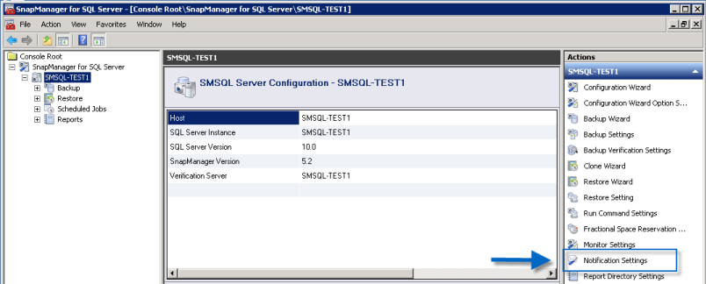
- Configure the desired notification settings.
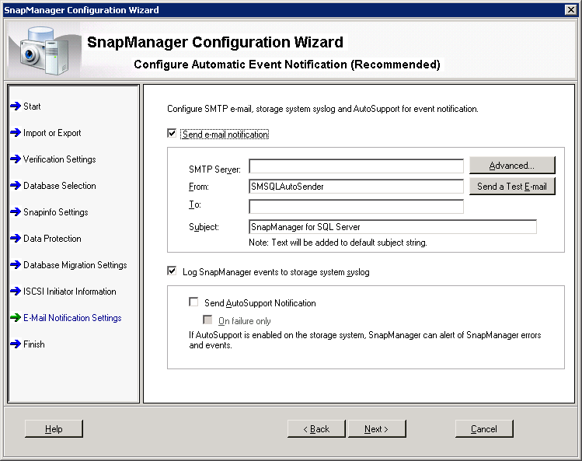
- When finished, click OK.

SnapManager 6.1 for SharePoint

Database Migration Wizard
SMSP 6.1 allows the Migration wizard to run only interactively. Later versions may support automation through either the command line or a parameter file. The Migration wizard makes it possible for the user to move content databases from a local disk to a LUN to enable management by SMSP 6.1. To move SharePoint content databases, the wizard performs the following steps:
- The wizard unmounts the databases in a storage group, moves the content database and transaction log files to the selected LUN, and remounts the databases.
SMSP 6.1 takes Microsoft SQL Server databases offline during the move operation.
- The wizard creates a SnapInfo directory that SMSP 6.1 uses to store information about the backup sets and the backed-up transaction logs.
- The wizard walks the user through the configuration settings. These settings include enabling the notification of SnapManager events through either e-mail, the storage system Syslog, or the AutoSupport feature.

Migrate Content Database to NetApp LUNs by Using SnapManager for SQL
Alternatively, the content databases can be migrated to NetApp LUNs by using SMSQL. To use SMSQL, complete the following steps:
- Log in to the SharePoint Database/Index Migration tool.
- Stop the following services in the SharePoint Server farm:
- SharePoint Services Administration
- SharePoint Services Search
- SharePoint Services Timer
- SharePoint Services VSS Writer
- SharePoint Services Tracing
- IIS Service
- Office SharePoint Server Search
- World Wide Web Publishing
These services can be started or stopped by using a PowerShell script. The following example is a sample script to stop these services.
Stop-Service -Name "SPAdminV4"
Stop-Service -Name "SPTimerV4"
Stop-Service -Name "SPTraceV4"
Stop-Service -Name "SPWriterV4"
Stop-Service -Name "SPSearchV4"
Stop-Service -Name "W3SVC"
Stop-Service -Name "IISADMIN"
Stop-Service -Name "SSoSrv"
Stop-Service -Name "SPSearch4"
- Use the SMSQL Configuration wizard to move SharePoint Server databases, such as the configuration database, the content database, the central administration console database, the search database, and the SSP database.
If the SnapVault integration feature of SMSP 6.1 will be used to archive backups of the SharePoint databases, make sure that the LUN is a qtree-based LUN and that it is the only LUN residing on the qtree.
- Restart the services listed in Step
2. The following example is a sample script to restart these services.
Restart-Service -Name "SPAdminV4"
Restart-Service -Name "SPTimerV4"
Restart-Service -Name "SPTraceV4"
Restart-Service -Name "SPWriterV4"
Restart-Service -Name "SPSearchV4"m
Restart-Service -Name "W3SVC"
Restart-Service -Name "IISADMIN"
Restart-Service -Name "SSoSrv"Restart-Service -Name "SPSearch4"

Migrate Content Database to Netapp LUNs by Using Migration Wizard
The database migration tool is used for the migration of SharePoint Server databases in SMSQL, such as the configuration database, the SSP database, or the Project Server database. To migrate databases, start the tool and complete the following steps:
- Start the SharePoint Server database and the Index Migration tool. Enter the Control Agent information in the fields provided, including address and port number. For the address, enter either an IP address or the computer name. Click Next.
- Select the SharePoint Server database on the left panel and a LUN in the Available Disc list on the right panel. Click the <=> button to show the database location.
- Click Reconfigure to change the database location or click Next to continue without changing the database location.
- Configure the SnapInfo directory with either the Single or the Advanced type.
- After the SnapInfo directory is configured, click Start. A dialog box is displayed as a reminder that the necessary SharePoint Server services will be stopped. If the server does not have SMSP Agent installed, it is necessary to stop the services manually.
Click the Show Detail button to view detailed information on which services will be restarted and on which servers have the SMSP Agent installed.
- Click OK to start the migration.
- Once the migration is completed, download the migration report.
If SharePoint Server databases share a LUN with Microsoft SQL Server system databases, only stream-based backup and restore can be utilized. SMSP 6.1 does not support this configuration. Always put SharePoint Server databases on different LUNs from the Microsoft SQL Server system database LUN. For more information, refer to the “SnapManager 5.1 for Microsoft SQL Server Installation and Administration Guide.”

Data Protection
SMSP 6.1 can perform full SharePoint Server farm-level backups and restore different levels of SharePoint Server components, from a single document version up to the contents of the entire farm.

Backup Builder
To back up a SharePoint Server environment, complete the following steps:
- Start SMSP 6.1 and select Data Protection > Backup Builder in the navigation pane.
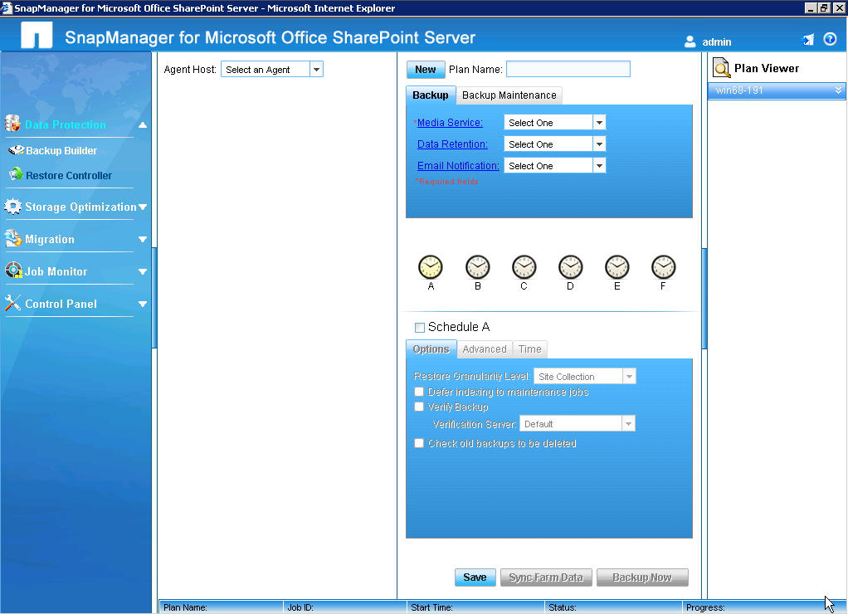
- Select an agent host. SMSP 6.1 auto-discovers the farm, and the various backup options can be set.
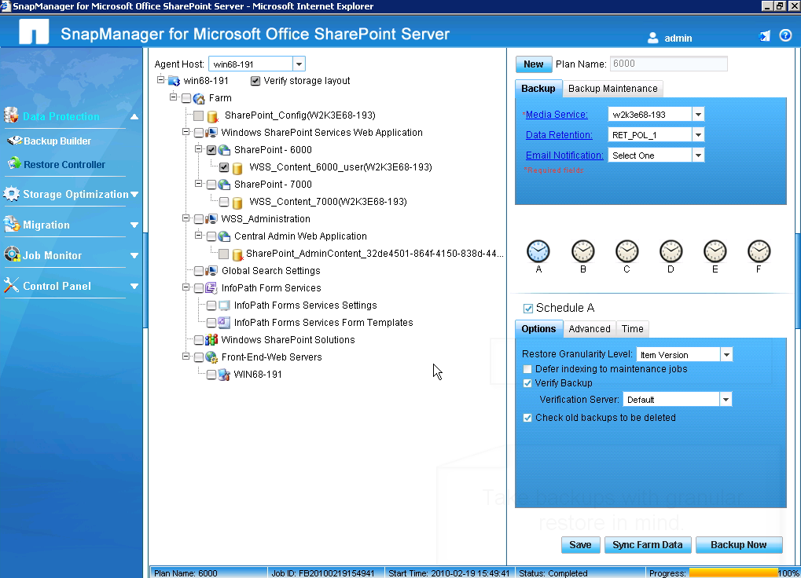
- Click the Backup Now button. SMSP 6.1 displays the SMMOSS dialog box:
  - From the Options tab, select Item in the Restore Granularity Level drop-down list.
  - Optional: The backup can be verified at this point by selecting Verify Backup.
  - Select the Remember These Settings checkbox.
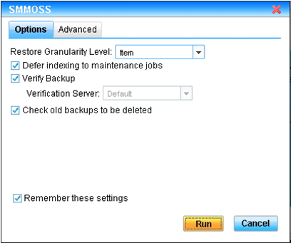
- The Advanced tab in the SMMOSS dialog box contains some optional settings. The SnapMirror options can be selected for mirroring the databases to a remote location and the SnapVault options can be selected for archiving the backup on NearStore.
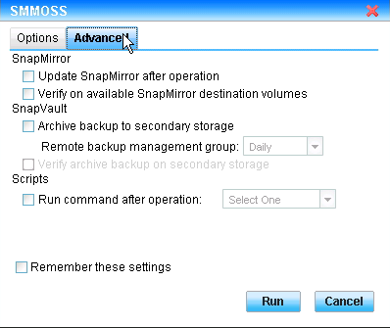
- The backup job can be monitored from the Job Monitor window.
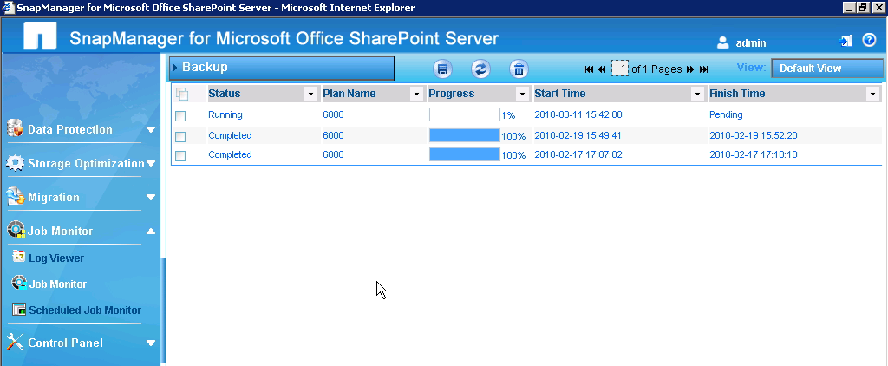
- Once the backup job is completed, the IIS footprint is backed up and the content database granularity is set to the item level.
- Back up the external data that is outside the content database of a SharePoint Server farm. Select Storage Optimization > Archived Data Recovery in the navigation pane:
  - Specify the backup schedule.
  - Specify retention requirements.
  - Click Save or click Run Now.
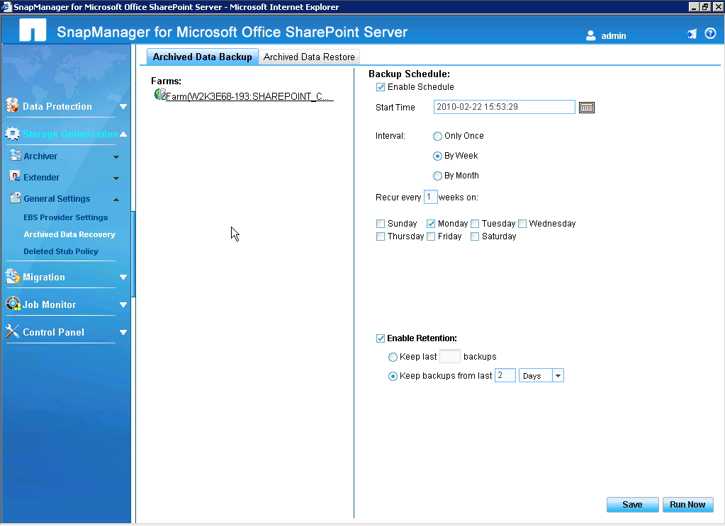
- Step
7 completes the backup process of the data external to the SharePoint server. This data is stored on a CIFS share.
Verification of backed-up databases must be performed by a nonclustered Microsoft SQL Server instance that is installed on either the local Windows server or another Windows server, which can be a dedicated verification server. The reason for this is that a virtual Microsoft SQL Server cannot be used for verifying database consistency. The LUN in the Snapshot copy is restored during the verification process, and the temporarily restored LUN cannot be a cluster resource. Therefore, the restored LUN cannot be included in the Microsoft SQL Server dependency list. A virtual Microsoft SQL Server instance can be used for verifying the online database.

Backup Job Scheduling
Use
Table 1 as a template for planning backup jobs.
Table
1) Backup job scheduling template.
Operation | Backup Job Name | Schedule
Backup Web apps content databases Soesterberg
Backup config databases Soesterberg
Backup Search Service online
Backup SSP schedule
SnapVault of database to NearStore
Physical verification of database files
Re-indexing of tables

Restore Controller
To perform an item-level restore of a document deleted from the SharePoint site, complete the following steps:
- Recover the document stub. Select the item-level restore feature in SMSP 6.1 and load the appropriate backup from Load Timeline. From SMSP Manager, select > Data Protection > Restore Controller.
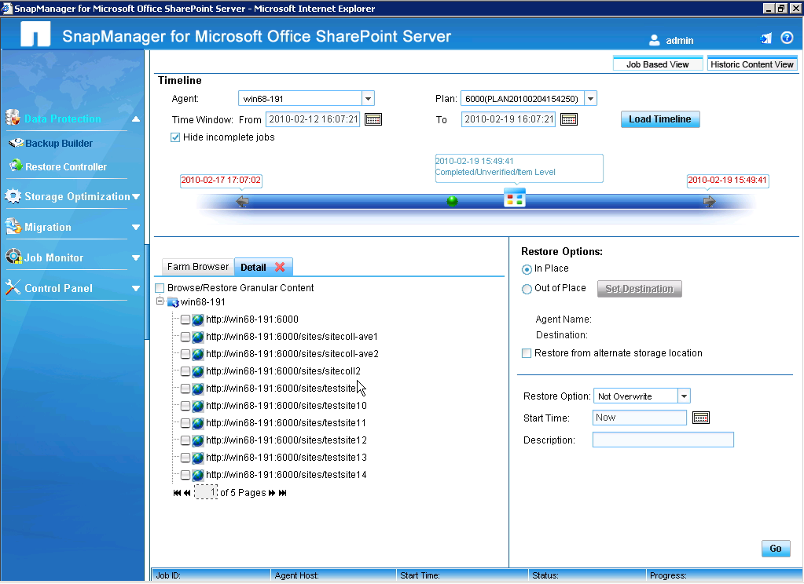
- Locate the document to be restored:
  - Select the site collection and the site.
  - Browse to the document by using the Farm Browser or the Detail tab (or use the I icon).
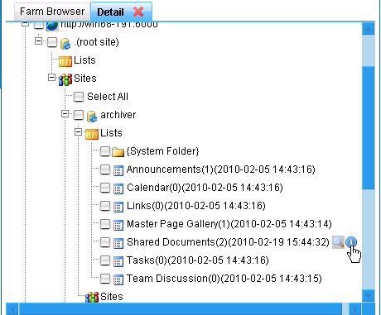
- Multiple pages of results may be displayed in this dialog box. Select the document to be restored and click OK.
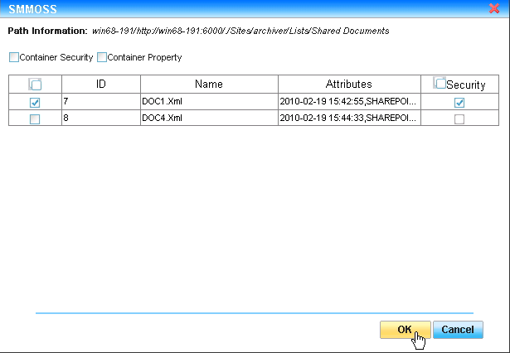
- In Restore Options, select In Place. Select Overwrite from the drop-down list and click Go. The job can be monitored from the Job Monitor window.
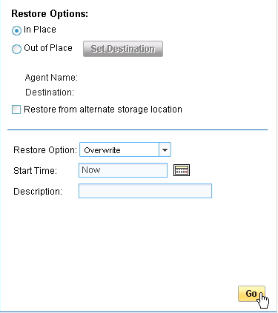
- At this point, the stub is back in the SharePoint Server farm, but the actual document is still missing. Select Storage Optimization > Archived Data Recovery > Archive Data Restore.
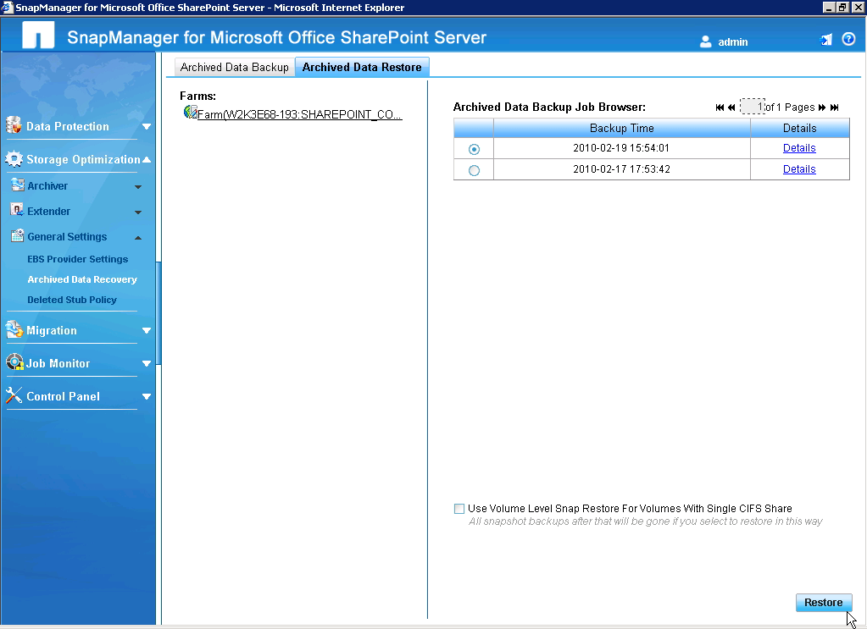
- Click Restore to restore the file that was deleted from the site.

SnapMirror
SnapMirror replicates data from the source system to the destination system and produces an online read-only copy of the data on the destination. SnapMirror can also send periodic or continuous updates to the destination to reflect incremental changes on the source. SnapMirror requires a license code and supports three modes of operation: asynchronous, semisynchronous, and synchronous.
To use SnapMirror, complete the following steps:
- Verify that SnapMirror is licensed on the storage controller by looking in /etc/snapmirror.conf (snapmirror on should be listed).
This step applies only to Data ONTAP operating in 7-Mode.
- Create the SnapMirror relationship between the source and the destination volume.
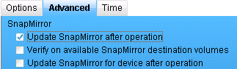
In SMSP Manager, SnapMirror can be used in the backup operation and in the backup maintenance plan. SMSP Manager has the capability to update the SnapMirror volume.

SnapVault
SnapVault can be configured for backups of SharePoint databases and for verification of SnapVault targets. For longer retention of backup data, database backup can be archived to a SnapVault destination when Protection Manager is configured for SMSQL.
To use SnapVault to archive database backups, complete the following steps:
- Install Protection Manager.
- Configure SnapDrive for Windows for DataFabric Manager server.
- In SMSP Manager, select Archive Backup to Secondary Storage.
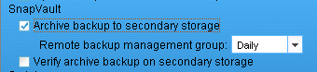

System Backup
A system backup protects all SMSP 6.1 configurations, such as the device configurations, the local derby database that has the SMSP 6.1 configuration, and so on. NetApp recommends creating a system backup of SMSP Manager on a network share or on a NetApp LUN. By default, a local system directory is specified in the Local Device path.
To create the system backup, complete the following steps:
- From the SMSP Manager interface, log in by using the service account user (demo\smspadmin).
- In SMSP Manager, go to System Recovery.
- Select Control Panel > SMSP Services > System Recovery.
- From the System Backup tab, select Local Device. Enter I:\Program Files\NetApp\SnapManager for SharePoint\UserData in the Path field.
Make sure that this path exists on the I: local device first. If it does not exist, create the directory structure on the I: drive.
- Click Test Device. A green checkmark with the Test Successful message validates that the destination has been set.
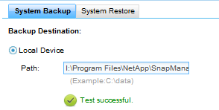
In this setting, the path for a NetApp LUN should be configured to back up all the system settings through an sdcli manual Snapshot scheduling. In this example, the system backup is placed in the same location as the Media Service backup LUN (I: drive).
- Click Save, and then click OK.
- Click Run Now to complete the backup process.

Configure Blob Storage Backup and Restore
To perform a backup and restore for BLOB storage data, complete the following steps:
- In SMSP Manager, the backup of the BLOB data can be created along with the farm data.
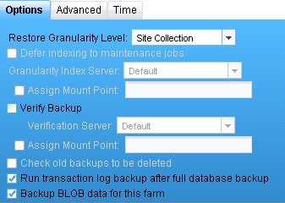
- Go to BLOB Provider Settings. Click on the farm name and verify if EBS or RBS is enabled under the General tab. Click the Settings tab to verify that the corresponding Web application has the status installed.
- Click Storage Optimization > General Settings > Archived Data Recovery.
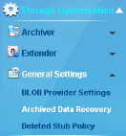
- In the Archived Data Backup tab, select Farm as the farm to be configured and click Save or Run Now.
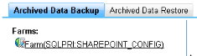
- Enable the schedule for BLOB storage backup:
  - Select the Enable Schedule checkbox.
  - Select a start time by using the calendar. Click OK.
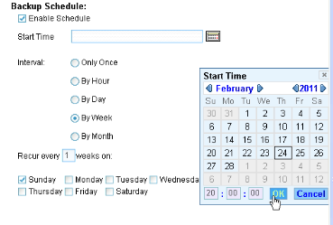
  - Select By Week for Interval.
  - Select the days of the week on which to run the backup.
  - Click Save.
- Click Run Now.
- Click Go to Job Report.
- Click the Refresh button to refresh the status of the job.
- Click View Detail Report to see the job details.
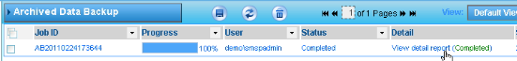
- Click Cancel.
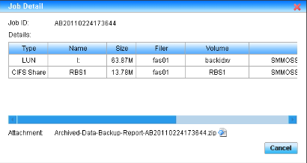
- In the Archived Data Restore tab, validate that the backups are showing up.
  - Click the Archived Data Restore tab.
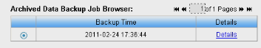
  - Click Details to show the job detail report of the corresponding backup Snapshot copies.
- To perform an archive data restore, select Backup Time and click Restore.

Configure SMSP Media Service
SMSP Media Service is the central component of the SMSP 6.1 architecture. SMSP Media Service communicates with the NetApp storage system for the BLOB storage data and the Archiver index as well as for all backup and restore jobs, backup metadata, and indexes. SMSP Media Service requires that the storage system and all data devices be configured to proceed with SMSP 6.1 management.
Table
2) SMSP Media Service configuration prerequisites.
Description
The CIFS shares for remote BLOB storage are created on the storage controller.
To configure Media Service, complete the following steps. Before starting, make sure the LUNs are mapped to the backidx and archidx LUNs on Media Service.
- Go to SMSP Manager and log in by using the admin user. Select Local System in the Log On To list.
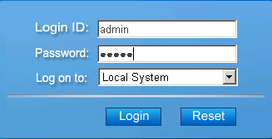
The admin user in Step
1 refers to the default SMSP 6.1 admin account.
- In SMSP Manager, go to Account Manager.
- Select Control Panel > SMSP Services > Account Manager.
- Add a new domain user to the service account:
  - Click the Add New User icon.
  - Select AD.
Selecting AD changes the available fields in the SMSP dialog box.
  - Type smspadmin as the user name of the new domain user. Click Find to search for the user in Active Directory.
  - Put this user in the SMSP Manager’s built-in administrators group by selecting Administrators in the Member Of list.
  - Click Save.
If changes were made successfully, a message is displayed indicating that the changes are saved and the new user is listed in the User Defined tab.
- Validate the new domain user:
  - Log out of SMSP Manager.
  - From the SMSP Manager interface, log back in by using the service account user name (smspadmin) in the domain and password.
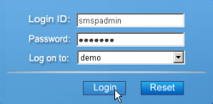
- In the left-hand navigation pane, click Control Panel > Data Management > Storage System.
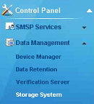
- Configure the storage system:
- Enter the following information:
- Profile Name: <Storage controller>
- Storage System: <Storage controller>
- Connection Type: RPC
- User name: Domain Name\administrator
- Scroll to the bottom of the window and click Test to test the admin user access, then click Save.
If changes were made successfully, a message is displayed indicating that the changes are saved.
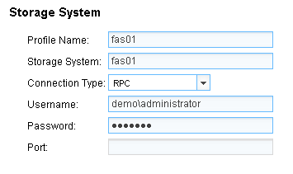
Make sure the host name of the storage system is in lowercase characters.
The user name used in this example is for the account that has the administrative privileges on the storage system. In this case, the user name is Domain Name\administrator for communication over RPC and root for communication over HTTP.
Be sure to use the HTTP connection type if this is a virtual server in a Cluster-Mode environment. When configuring the storage system in the Cluster-Mode environment, use the VSADMIN user name.

Configure Data Devices on SMSP Media Server
To configure data devices on Media Service, complete the following steps:
- From the SMSP Manager interface, log in by using the service account (smspadmin) user name and password.
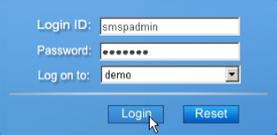
- In the left-hand navigation pane, click Control Panel > Data Management > Device Manager.
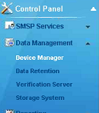
- Use the information in
Table 3 to configure data devices:
Table
3) Information for configuring data devices.
Device Name | Device Type | Filer | Share Name
RBS Store1 | CIFS share | <Storage controller> | RBS1
RBS Store2 | CIFS share | <Storage controller> | RBS2
MigrationDest | CIFS share | <Storage controller> | MIGRBS
ArchiverIndex | CIFS share
BackupIndex | CIFS share
- Add a device:
  - Locate the Device Manager section. Click Add under Physical Device on the right-hand side and specify CIFS share as the logical device name and data type. Complete the other fields, using the information in
Table 3.
Selecting CIFS share as the device type changes the field options from LUNs to Filer, Share Name, and UNC Path. Notice that UNC Path is populated with data from the Filer and from Share Name (\\<STORAGE CONTROLLER>\<<share_name>>).
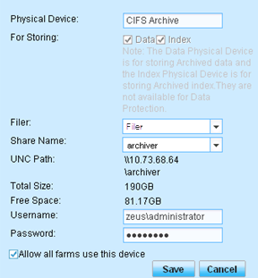
  - Scroll to the bottom of the window and click Test. Click Save.
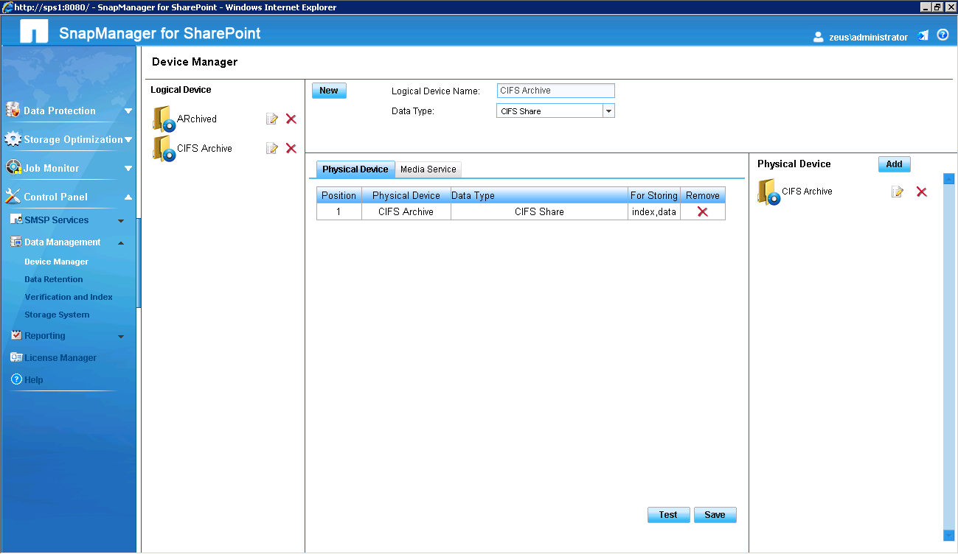
If changes were made successfully, a message is displayed indicating that the changes are saved.
  - The device name is now listed under Logical Device in the left-hand pane.
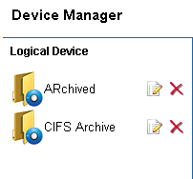
- Repeat Step
4 to create the other archived data devices, using the information in
Table 4.
Table
4) Information for configuring the other archived data devices.
Device Name | Device Type | Filer | Share Name
RBS Store1 | CIFS share | <Storage controller> | RBS1
RBS Store2 | CIFS share | <Storage controller> | RBS2
MigrationDest | CIFS share | <Storage controller> | MIGRBS
- Add an archived index device.
  - Select the Index checkbox. Enter ArchiverIndex as the device name.
  - Scroll to the bottom of the page and click Save. The saved device appears on the left pane under Logical Device.
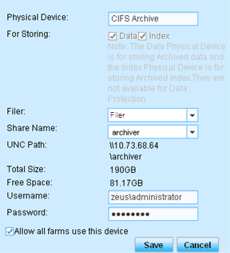
- In Windows Explorer (or equivalent), navigate to the following file path to validate that the I:\Program Files\NetApp\SnapManager backup location for SharePoint\VaultServer\Media\data-backup was created:
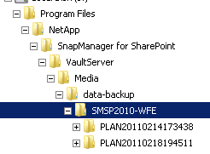
This is the location where all of the SharePoint front-end components are backed up as streaming-based backup.

Integrate SnapManager 6.1 for SharePoint with SCOM
SMSP 6.1 logs events in the Windows Event Viewer and uses MOM and SCOM to monitor these events. If the environment has a SCOM server, complete the following steps to integrate SMSP 6.1 with the SCOM server:
- Open SMSP 6.1 Manager and select Control Panel > SCOM Settings.
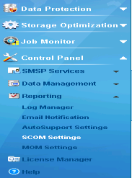
- Select the Enable SCOM Integration option. Enter the SCOM server name and the local host full name.
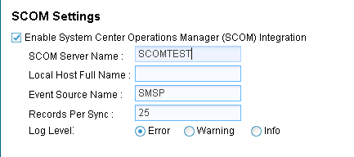
- After entering all details, click Test. If the test is successful, click Apply.

Integrate SnapManager 6.1 for SharePoint with Fast Search Server Farms
SMSP 6.1 can create backups and restores of FAST Search Server for SharePoint 2010. After FAST Search for SharePoint 2010 is installed, install the SMSP Member Agent on all FAST Servers. These are the steps to check:
- Verify that the FAST Search Server is running:
  - Log in to the FAST server.
  - Open the Administrator shell for FAST Search Server for SharePoint 2010.
  - Run the ncrtl status command.
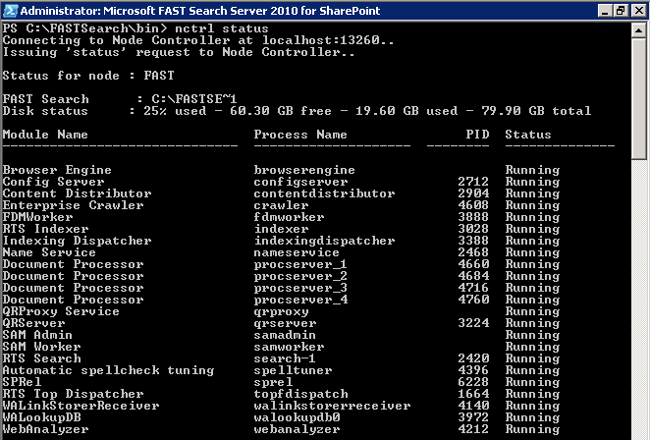
- In SMSP Manager, select Control Service > SMSP Services > Control Service.
- Click the Agent Monitor tab. If the FAST Search Server appears in the agent group and the status shows as Up, then SMSP Member Agent is available on FAST Search Server.
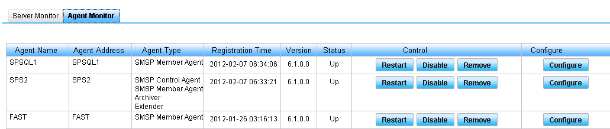
- In SMSP Manager, select Data Protection > Backup Builder.
- Select a farm name and Agent. This step shows the complete list of databases available in the farm, including the FAST Search database.

