FAS2220 Entry Level FAS backup to Tape options

I often get asked about the different ways to back up to tape with NetApp storage especially for the entry level market. Traditionally with the older FAS2020 generation of products it was fairly straightforward with the FAS directly connecting to tape using the on-board FC ports.

Alternatively there was the option to add SCSI cards to certain FAS to directly attach to SCSI tape libraries. This option was limited to FAS devices which supported SCSI expansion cards (which didn’t include the entry level FAS device).

With the latest product release, the FAS2220 removed both the above options due to having no on-board FC ports and no FC/SCSI expansion card support.

I then had the following question put forward to me by a partner….

We are looking to sell a 2220 and the usual method we backup NetApp is to directly attach an FC tape library and use BE or similar to do an NMDP dump…

Obviously 2220 doesn’t have FC, is there an option to do an NDMP dump over the LAN, as I have a tape drive locally attached to a Windows Server running BackupExec and then run the NDMP backup over the standard LAN network interfaces?

I made this my mission to find a simple straightforward solution offering.

After looking around the NetApp field portal and using other resources, it was proving difficult to find an answer and I believe this is the case for many partners. Many partners were happy to use the direct FC connectivity for their tape libraries and were unfamiliar with any alternative methods.

After tracking down all the relevant details, I decided to compile this post which I hope will be of some benefit highlighting the newer methods which can be used, especially with the latest entry level FAS systems.

What did I find? In summary, you can use the following methods (on all new FAS22xx, FAS32xx & FAS62xx systems):

- Direct SAS connectivity to tape is supported i.e. A SAS connected tape library directly attached to a FASS2220 controller. (Reference page 20 - Data ONTAP 8.1 7-Mode - Data Protection - Tape Backup and Recovery Guide)
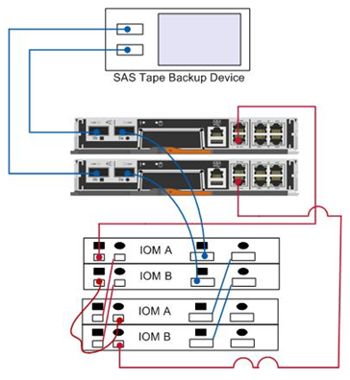
- Network attached connectivity to tape is supported with a host using NDMP i.e. A host using NDMP in between the controller & tape library and therefore not requiring FC or SCSI connectivity directly from the controller.
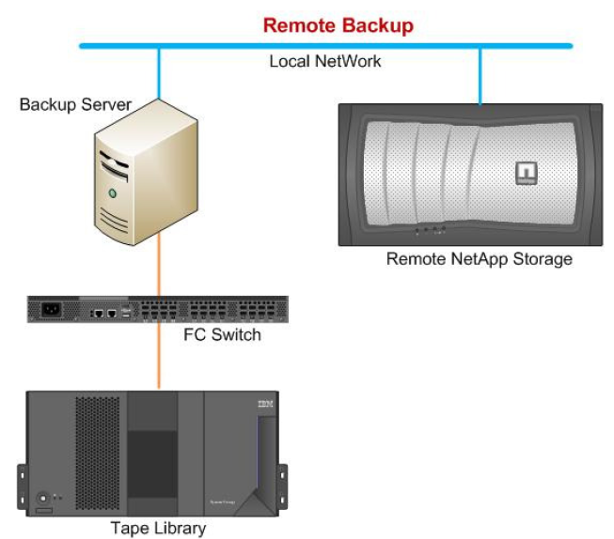
Note: there are many more methods which can be used but the two methods above will help to provide a solution for the NetApp entry level systems

Please see the links below for more detail and diagrams.

SAS connectivity
FAS2220 Storage and Network Configuration Guide (page 10 onwards):
https://fieldportal.netapp.com/Core/DownloadDoc.aspx?documentID=73217&contentID=75791
Note: The SAS ports don’t need to be configured like the FC ports.

But as you can check on the following link, only HP LTO 4 and 5 with SAS are supported with Data ONTAP 8.1.1:
http://www.netapp.com/us/solutions/a-z/data-protection-devices.html

But in case you don’t want/can’t use a SAS tape device, you can backup to tape through the network using an NDMP server on the middle of the way (such as Backup exec):
https://kb.netapp.com/support/index?page=content&id=1010645&actp=search&viewlocale=en_US&searchid=1352815101105

Network Attached with NDMP host
Tape Backup with NDMP host:
https://fieldportal.netapp.com/Core/DownloadDoc.aspx?documentID=74132&contentID=76301

An old but useful link on the Symantec website:
How to perform a backup of NDMP Filers (NAS) with the Symantec Backup Exec 11d (and above) for Windows Servers Network Data Management Protocol (NDMP) Option http://www.symantec.com/business/support/index?page=content&id=TECH48957

For more information on Data Protection, please refer to the Data ONTAP 8.1 7-Mode - Data Protection - Tape Backup and Recovery Guide:
https://library.netapp.com/ecm/ecm_get_file/ECMM1277853

Please let me know if you have any additional thoughts, suggestions or queries on this topic or whether you found this post useful.

Best Regards,
Adrian

