Information in System Manager GUI.
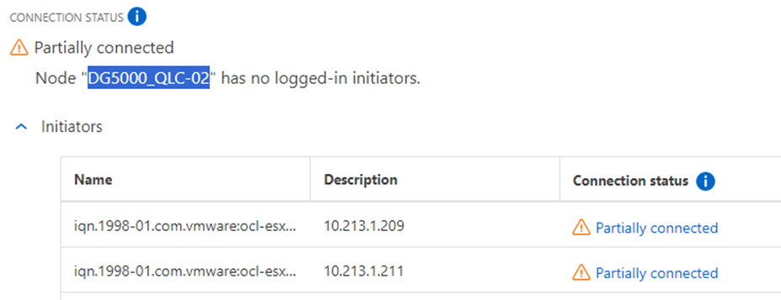

Information in ontap cli shows active iscsi sessions on both controller nodes.

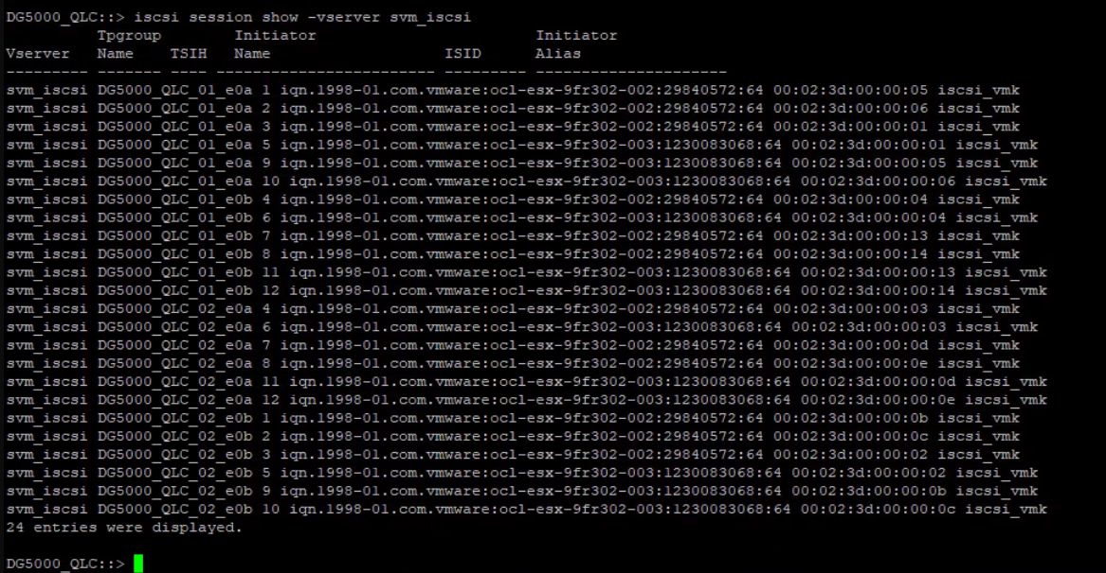

Information in esxcli shows active iscsi sessions from both controller nodes.

