Information in System Manager GUI.
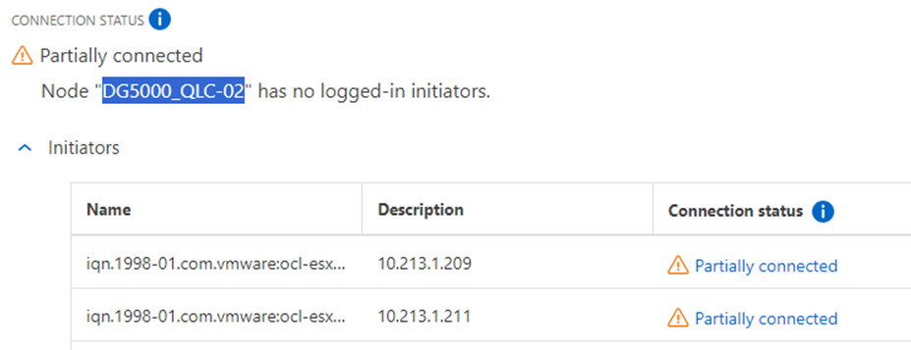
Information in ontap cli shows active iscsi sessions on both controller nodes.
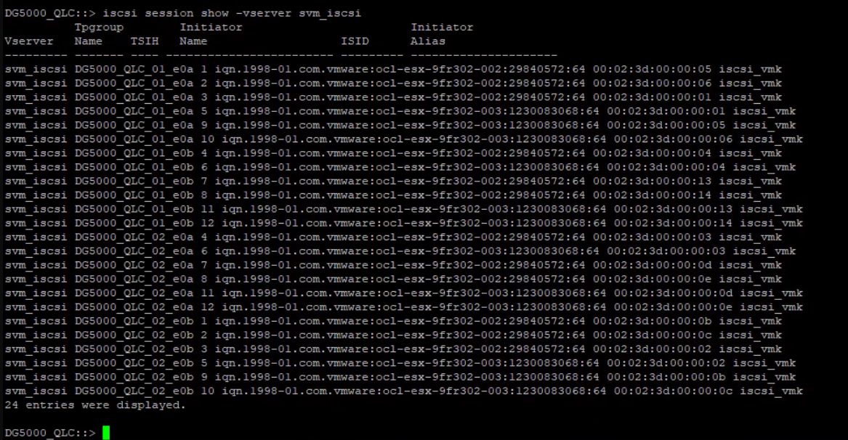

Information in esxcli shows active iscsi sessions from both controller nodes.
