

Storage Provisioning for MS SQL Database Application

Abstract
The purpose of the document is to guide the users through the usage of this workflow and its components and functionalities.

TABLE OF CONTENTS

  - Pre-requisites for this solution…………………………………………………….3
1.2 Workflow Automation components included……………………………………..3
2 The Workflow
2.1 Storage Provisioning for MS SQL Database Application...………….…………….3
2.2 Goal…………………………………………………………………………………4
2.3 Storage and Initiator Input parameters................................................…..........5
2.4 Database Size Input parameters...........................................................................…...5
2.5 Result………………………………………………………………………………..6
2.6 Error Handling………………………………………………………………………6

1.1 Pre-requisites for this solution
The installation of this solution set requires that certain products and applications have previously been installed. Please ensure that the following solutions have been deployed and configured:
1) OnCommand Workflow Automation 2.0
2) OnCommand Workflow Automation Unified Manager data source
3) Before running this workflow, the storage should be discovered by the host iscsi initiator and the host should be connected to the storage on which the luns are getting provisioned.

1.2 Workflow Automation components included

Workflows:
Storage Provisioning for MS SQL Database Application
Commands:
Create volume_sql
Create LUN
Create igroup_sql
Map LUN

2 The Workflow
Below are screenshot examples and overviews of the workflow.
2.1 Storage Provisioning for MS SQL Database Application
This Workflow is designed to for Storage Provisioning of a MS SQL Database Application on a windows machine. This Workflow takes the input from the user for the size of the lun to be created for the MS SQL databases which is composed of System Db, Temporary Db, Data Db and Transaction logs Db. The workflow design is based on the TR-3693.The System Db Lun is the place where the MS SQL Installation and system files are stored. The Temporary Db Lun is where the temp data of the database is stored all the data is stored here before it is written to the database. The data Db Lun is where all the database data is stored and Transaction Logs Db is where all the logs related to the database transactions is stored. For all the Volumes there is some snapshot reserve percentage except the Temporary Db volume as the data present here need not be backed up for recovery in case of data loss.
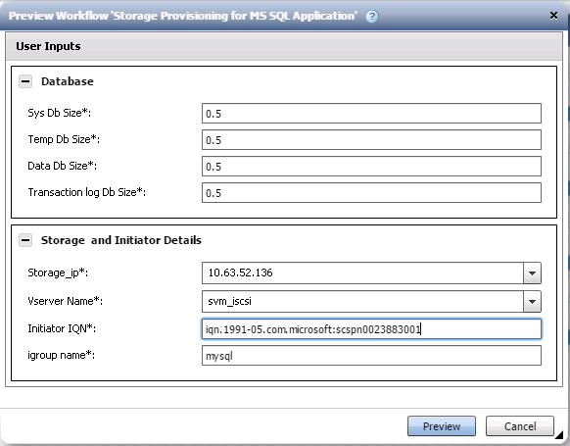

2.2 Goal
This workflow will automate the provisioning of the C-mode storage objects associated with an MS SQL database. In this sample, the workflow creates volumes and Lun's for the MS SQL data Db, System Db, Temporary Db, Transaction Log Db.
This workflow includes:
· Creation of MS SQL Lun's based on the workflow inputs
· Sizing the Lun's based on the usable size provided as user input

2.3 Storage and Initiator Input parameters
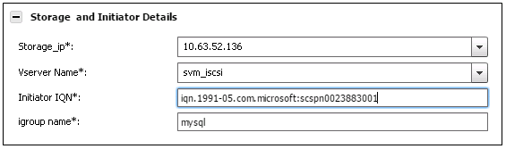
1) Storage IP (required)
This is a dropdown selection of the Storage Server IP on which the Lun's need to be created.
2) Vservername (required)
This is a dropdown selection, of the data vservers which serve iscsi luns.
3) IQN Name (required)
This is the IQN Name of the Initiator Host.
4)Igroup Name(required)
This is the name of the igroup to which the host belongs.

2.4 Database Size Input parameters
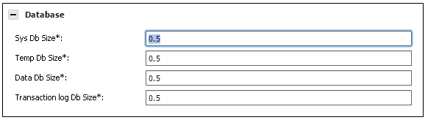
1) Total SYS Db Size (required)
The usable size in GB you would like for the MS SQL System Db Lun. Valid values are from 0.5GB to 500GB.

2) Total Temporary Db Size (required)
The usable size in GB you would like for the MS SQL Temporary Db Lun. Valid values are from 0.5GB to 500GB.
3) Total Data Db Size (required)
The usable size in GB you would like for the MS SQL Data Db Lun. Valid values are from 0.5GB to 500GB
4) Total Transaction Log Db Size (required)
The usable size in GB you would like for the MS SQL Transaction Log Db. Valid values are from 0.5GB to 500GB

2.5 Result
The workflow will result in creating the C-mode volumes & Luns required for a MS SQL database.

2.6 Error handling
An error message is displayed if there is no storage controller or aggregate with enough capacity to fulfill the storage provisioning request.

