- Login to maintenance console of OPM 2.1 as umadmin
- ON the main menu, select option 2 “Unified Manager Integration”
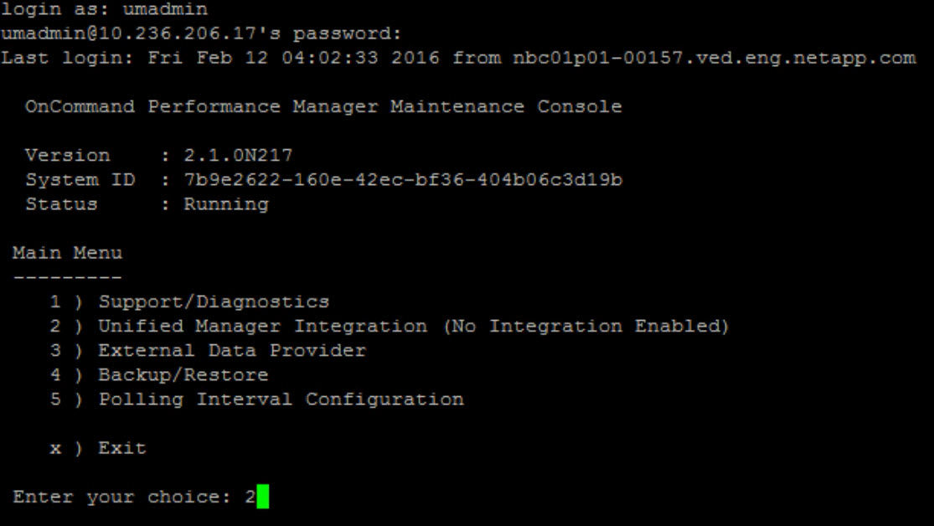

- Once selected, you will be asked whether you want “Full Integration” or “Partial Integration”, you need to select option1 – Full integration as shown below
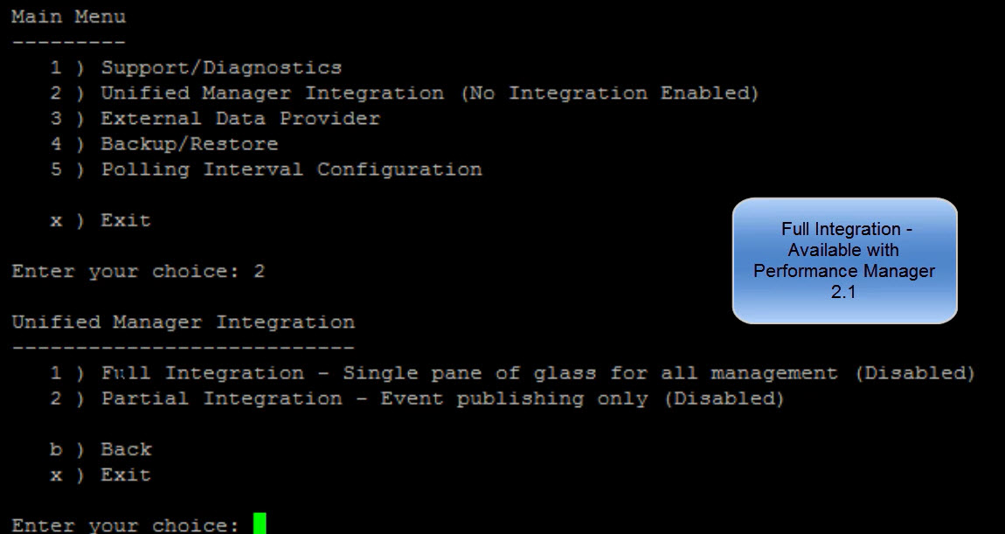

- You will now see the Full Integration menu, here you need to select option2 – Enable Full Integration
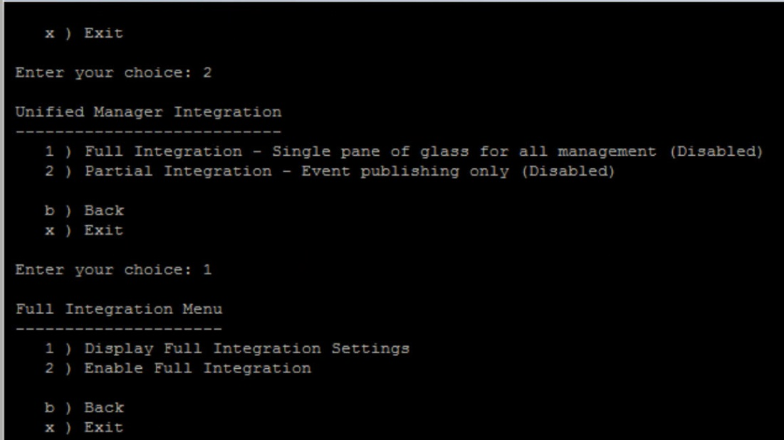

- Confirm the integration and select “y” to continue
- Key in OCUM FQDN and credentials that will be asked here. Please follow the steps mentioned in the integration process
- Once the integration is complete, you will need to restart the OPM instance before you can use UM IP address.
- You will now login to the OCUM web interface and navigate to add cluster wizard. Here you can select the OPM instance you just integrated for this purpose.
