Destination Volume Migration in DFM 4.0/OnCommand 5.0
- Run the dfpm CLI: “dfpm dataset list -m <dataset name or id>” to find out the destination volume as follows,

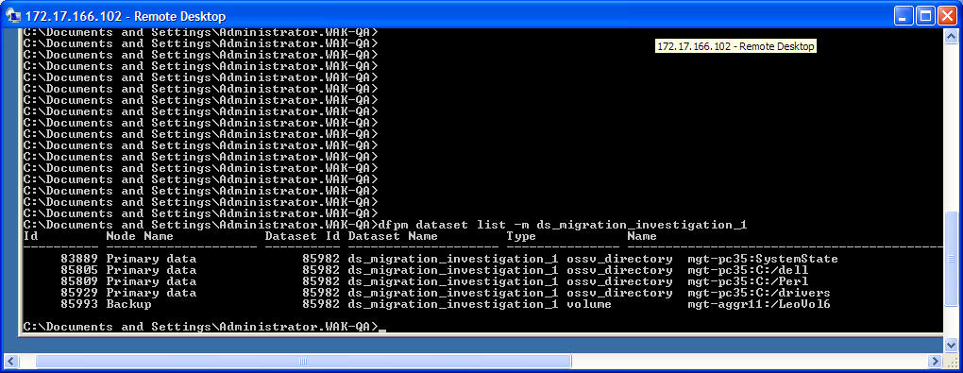

- Use FilerView to find out in which aggregate a destination volume, such as ‘LeoVol6’, is located.
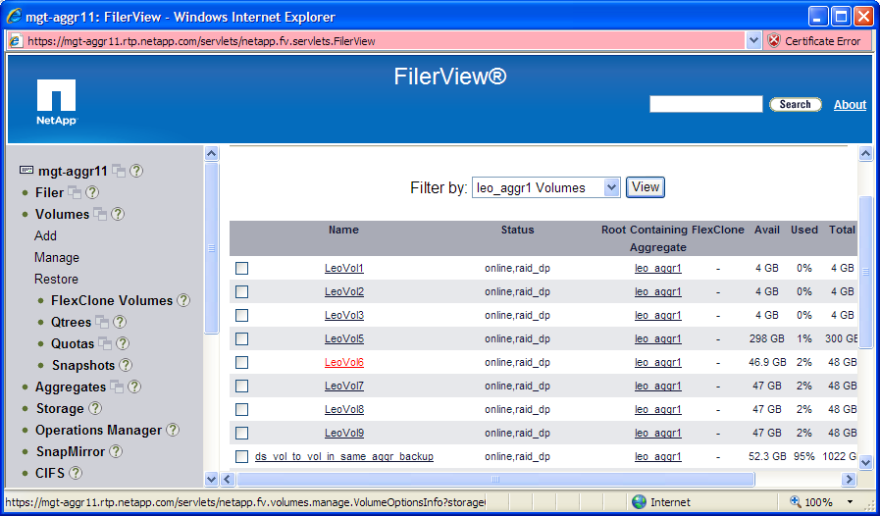
LeoVol6 is located in the aggregate: ‘leo_aggr1’ on the filer: ‘mgt-aggr11’.
- Choose Hosts/Aggregates to open the Aggregates window as follows,
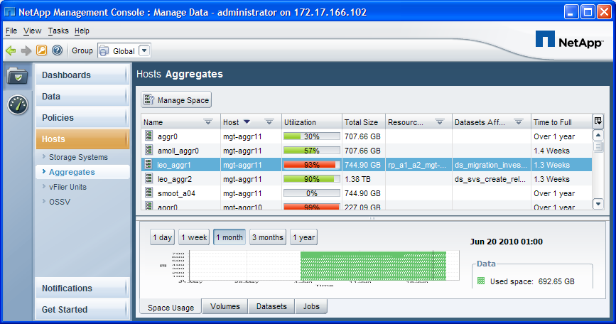

Select the aggregate: ‘leo_aggr1’ and click the “Manage Space” button at the top of the window.
- The Secondary Space Management (SSN) wizard will pop up as follows,
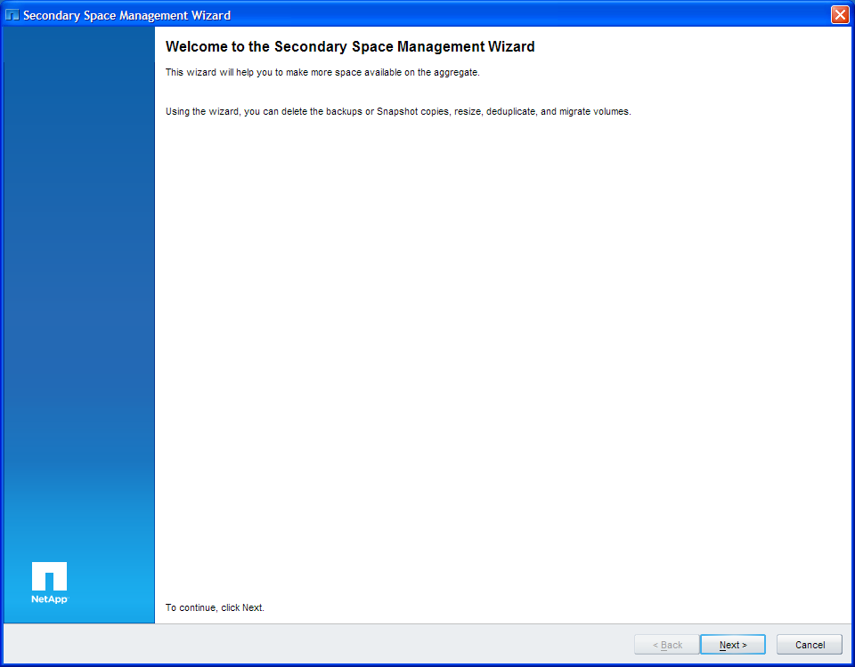

- Click Next button, you will get the screenshot as follows,

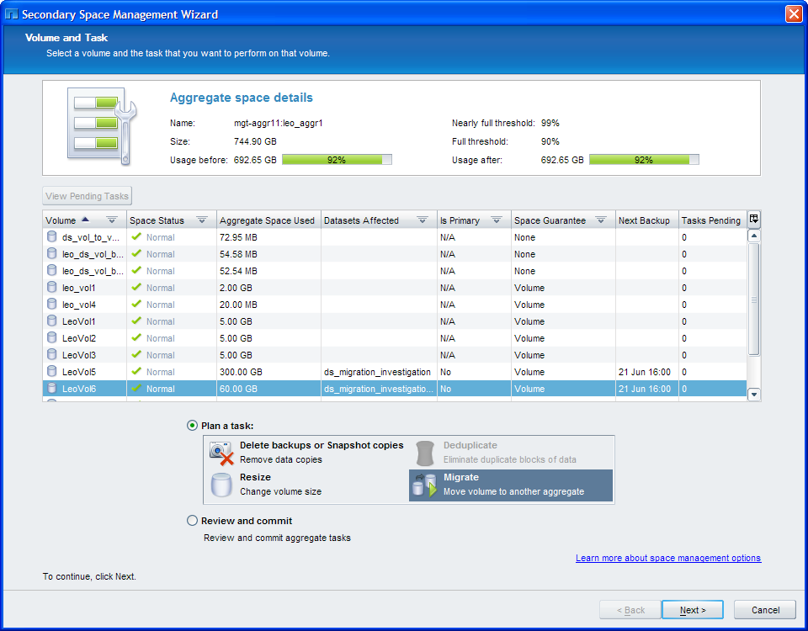

- Click Next button and you will get the screenshot as follows,

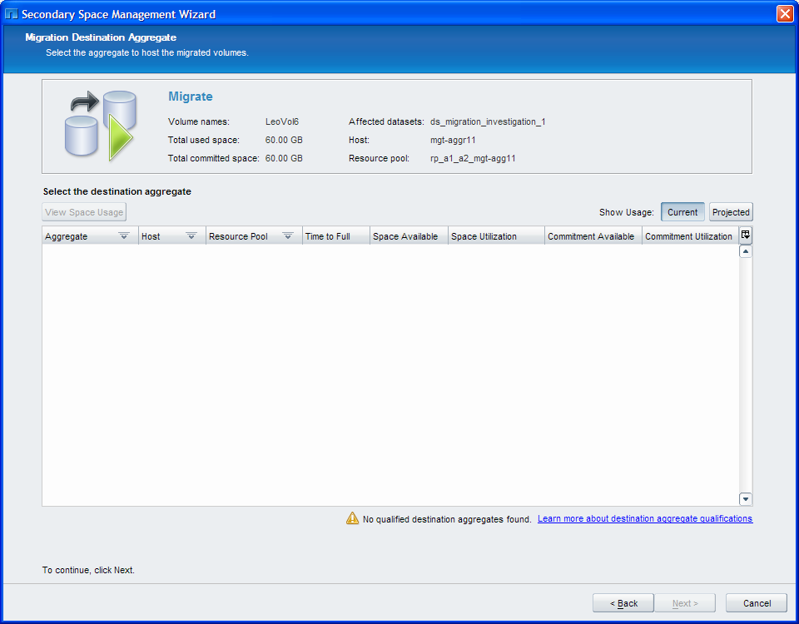

There isn’t any aggregate candidate you can select from.

- Run the dfpm CLI: ”dfpm migrate volume -D mgt-aggr11:/LeoVol6” to find out why we haven’t got any aggregate candidate above.

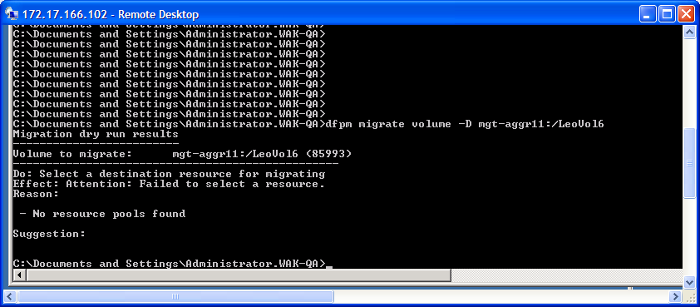

Ok. We need to attach a resource pool to the destination node to provide the space for the new destination volume.

- Choose Data/Resource Pools to create a new resource pool as follows,
Click Add menu item at the top and get the Add Resource Pool Wizard popped up as follows,

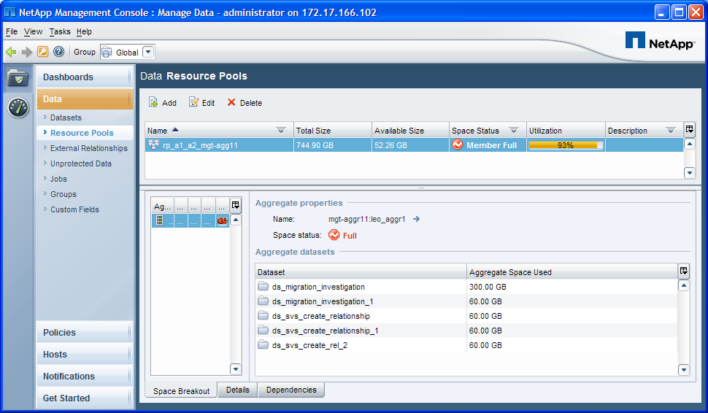

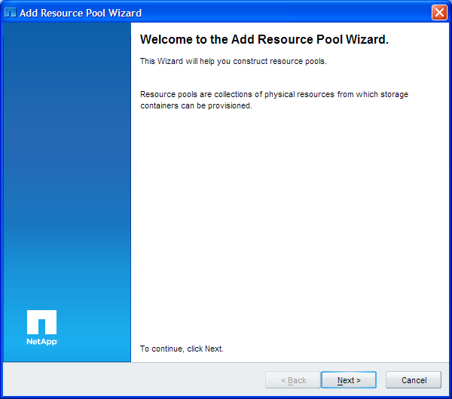

Click Next button, you will get,

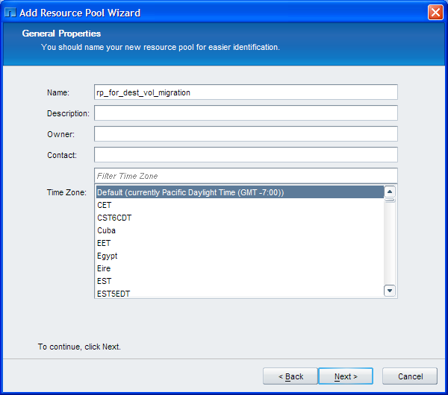

Type in the resource pool name: ‘rp_for_dest_vol_migration’ and click Next button, you will get,

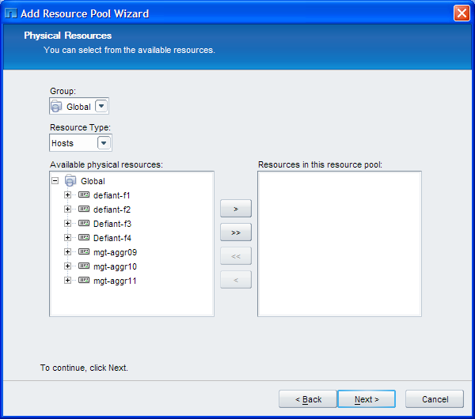

Select an aggregate which has enough space to contain the new destination volume as follows,

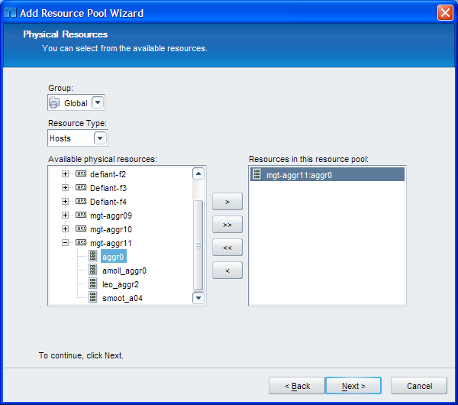

Click Next button, you will get,

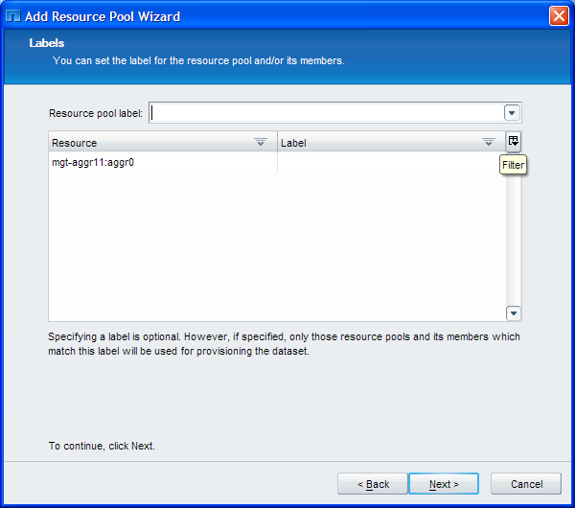

Click Next button again, you will get,

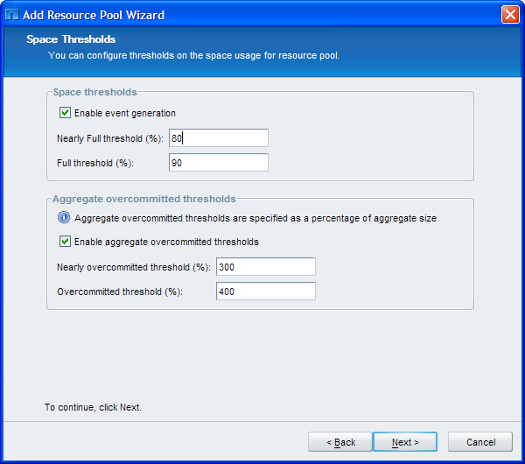

You can change thresholds here or leave them alone. Click Next button, you will get,

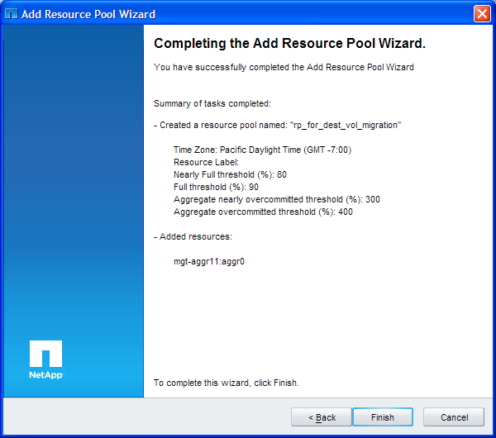

Click Finish button to complete the resource pool creation and you will see the resource pool has been created as follows,

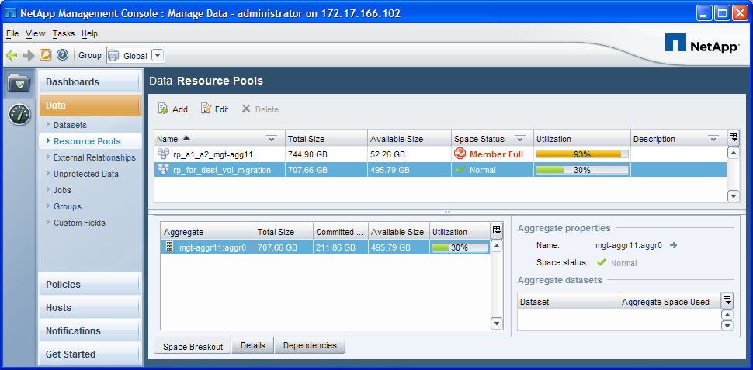

- Go back to Data Datasets window to attach the resource pool to the destination node of the dataset: ‘ds_migration_investigation_1’ as follows,

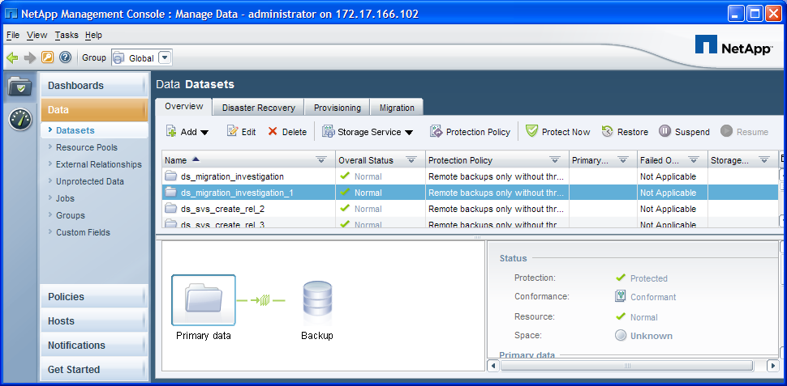

Click Edit menu item, you will get,

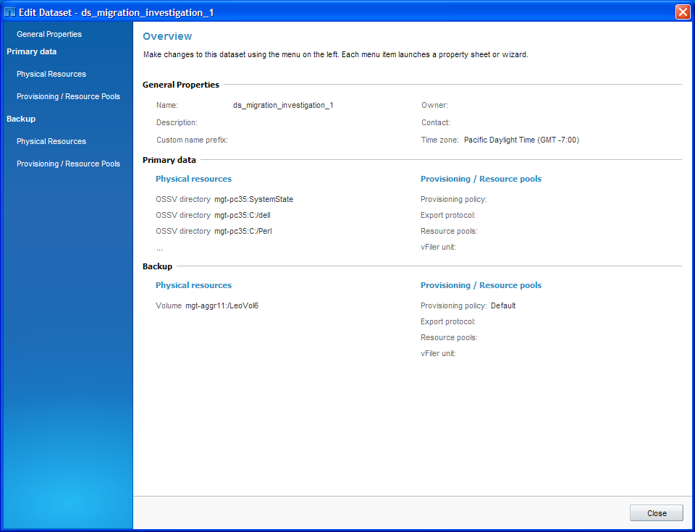

Choose Provisioning/Resource Pools for Backup node, you will get,

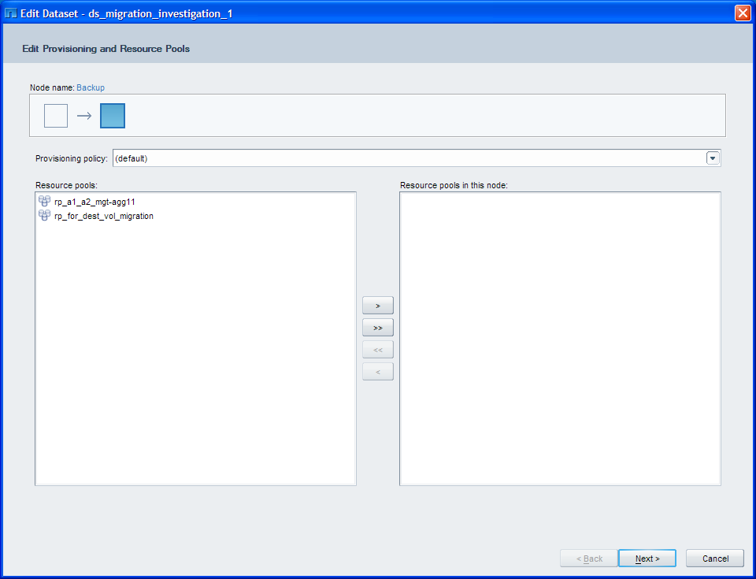

Select the resource pool ‘rp_for_dest_vol_migration’ as follows,

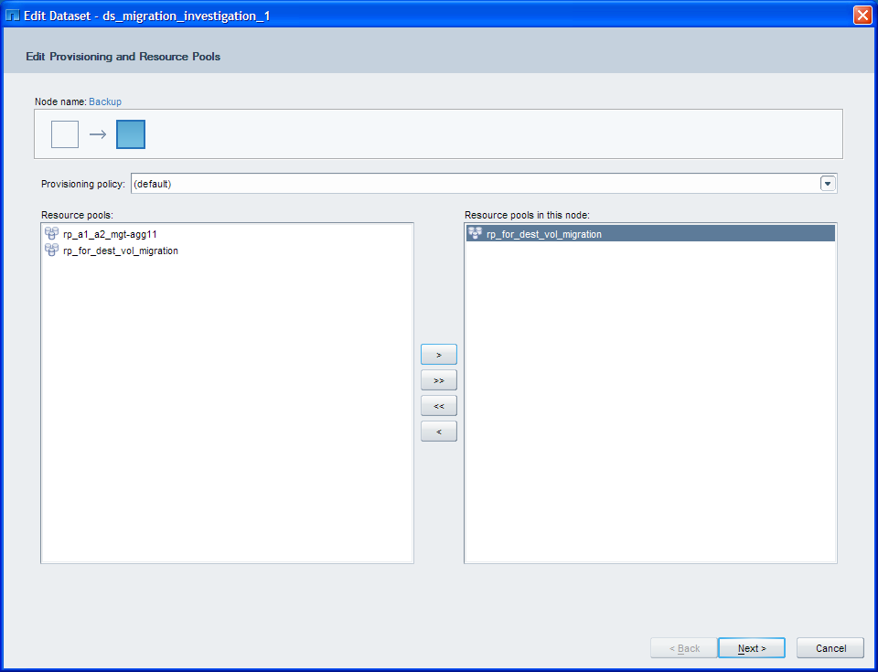

Click Next button twice, you will get,

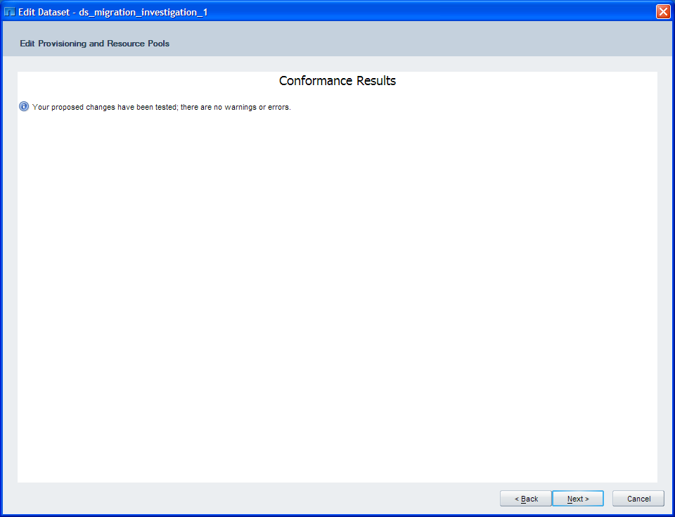

Click Next button again to get the screenshot as follows,

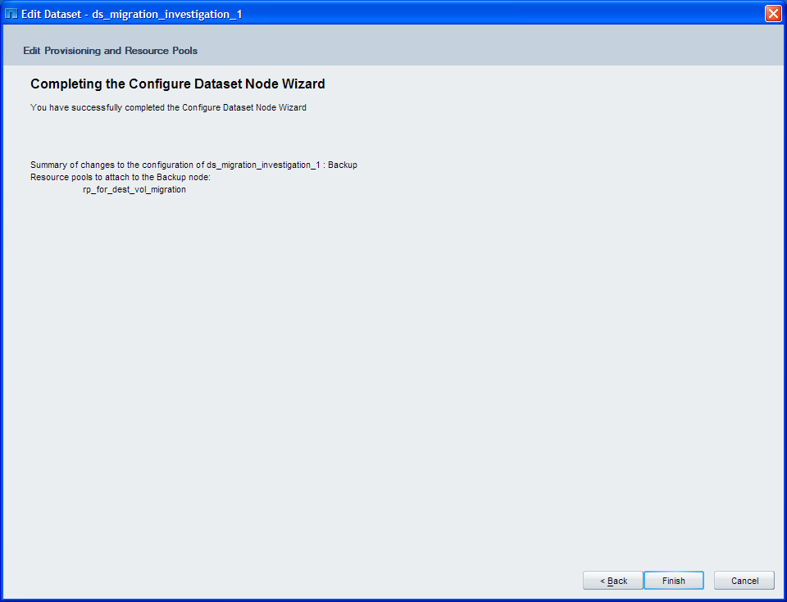

Click Finish button to complete the operation.

- Go back to Hosts Aggregates window in step 3 as follows,

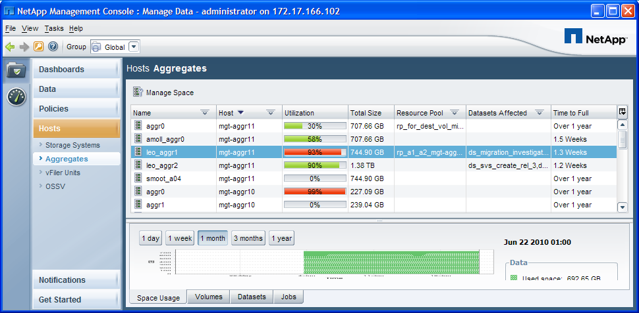

- Launch SSM wizard, select the volume: ‘LeoVol6’ and click Migrate button, you will get,

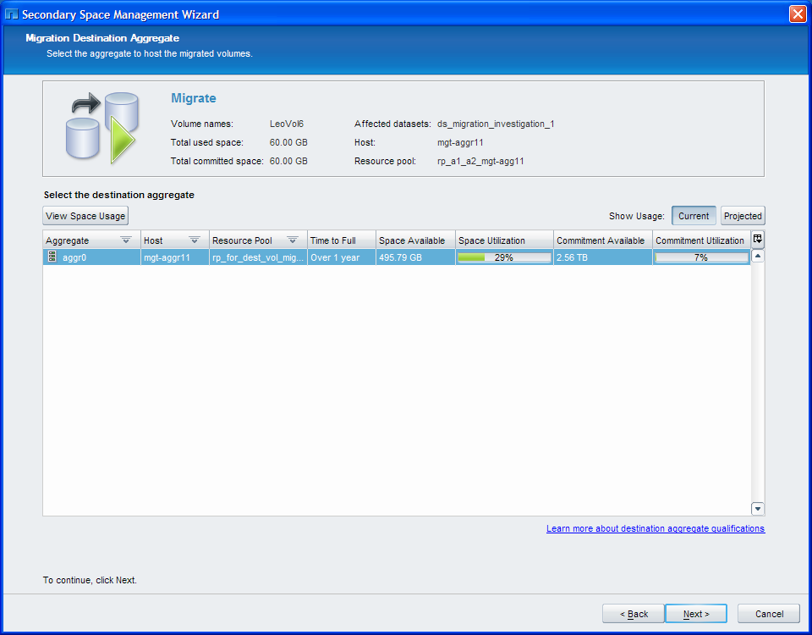
So we get a destination aggregate candidate now.

- Select the candidate and click Next button, you will get,

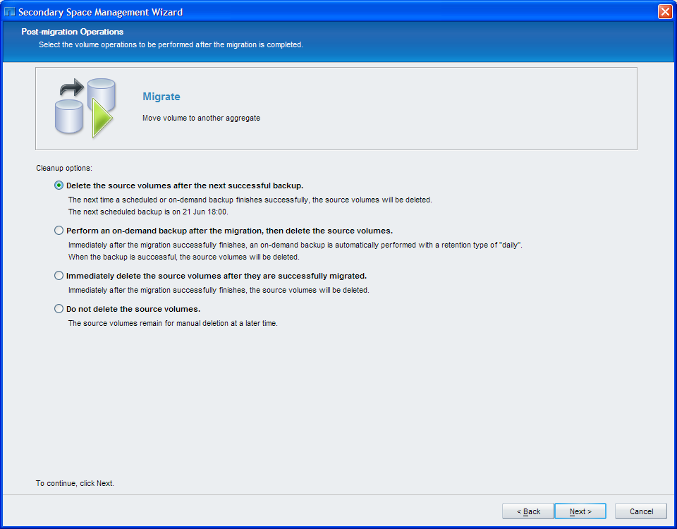

- Select the option: “Immediately delete the source volumes after they are successfully migrated”
and click Next button, you will get,

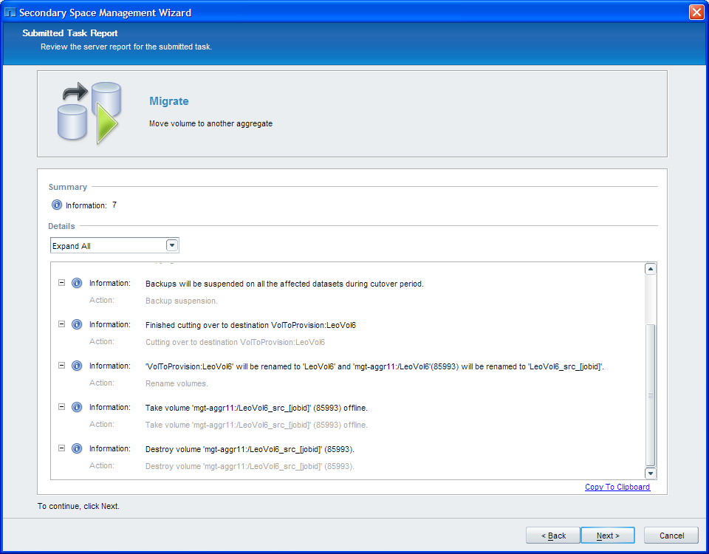

- Click Next button, you will get,

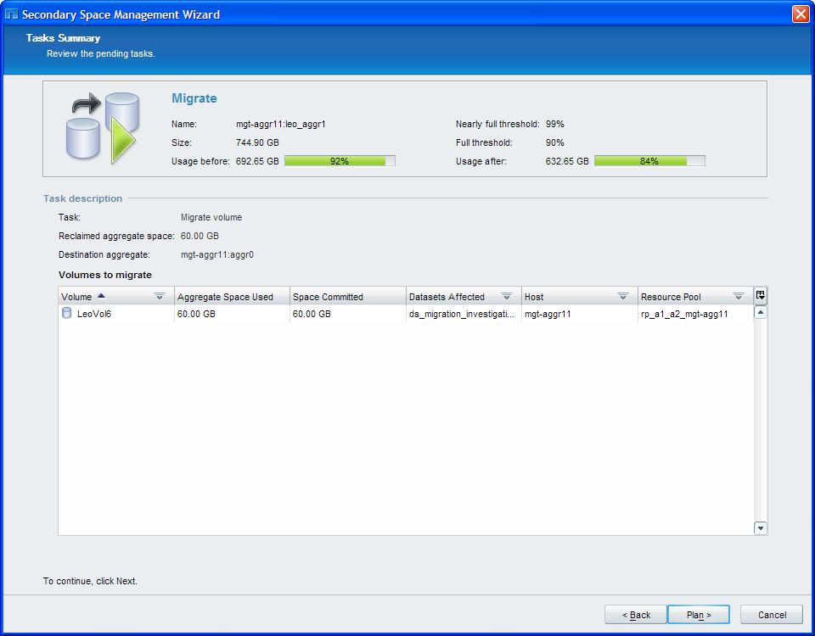

- Click Plan button, you will get,

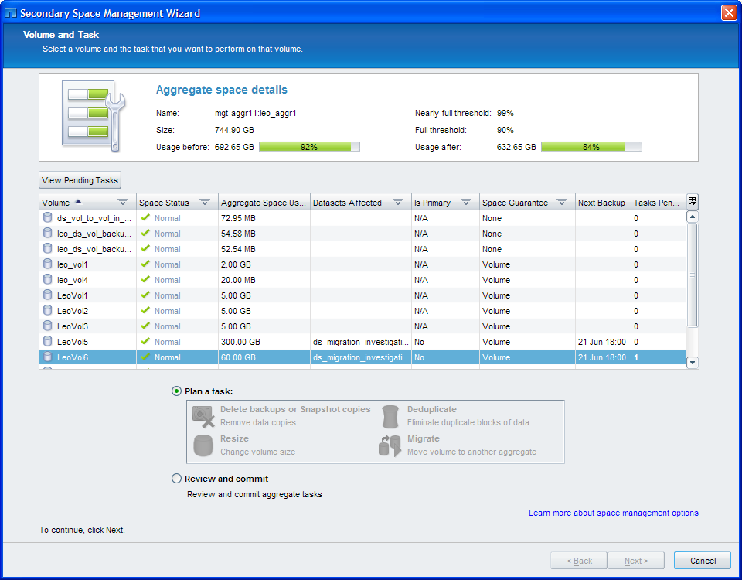

- Select the option: “Review and commit” and click Next button, you will get,

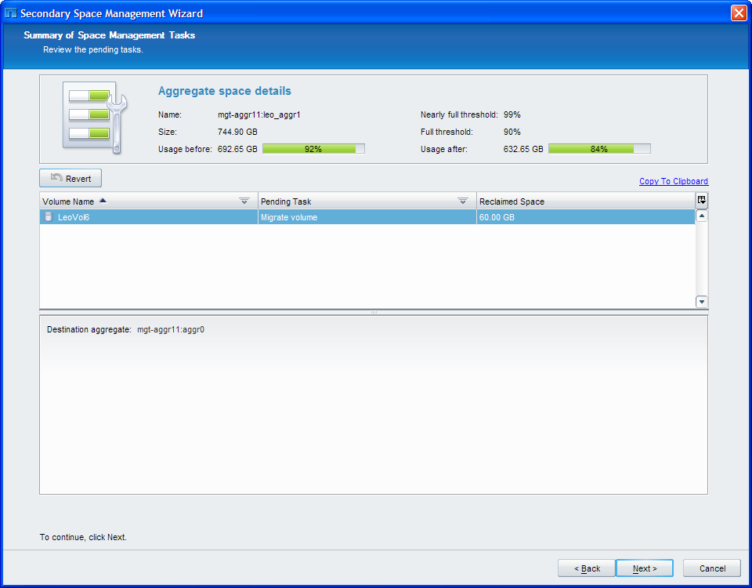

- Click Next button, you will get,

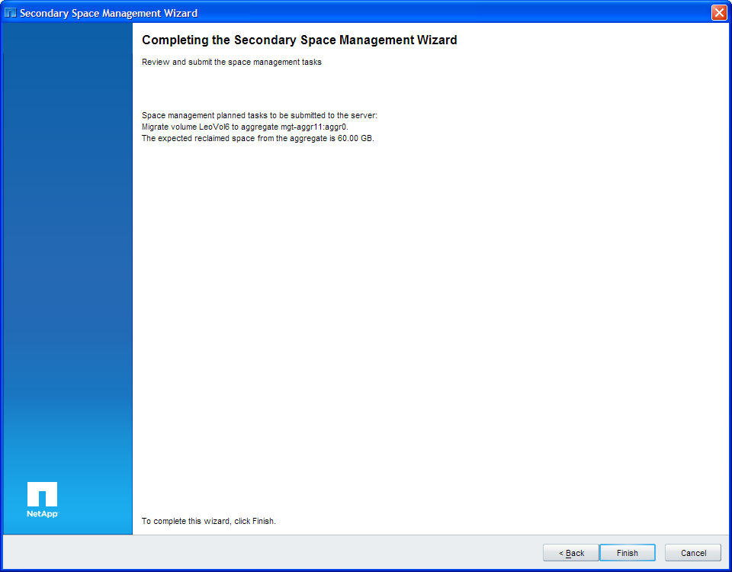

- Click Finish button to complete the migration process and start the migration job.
Go to Data Jobs window and you will see the migration job is running as follows,

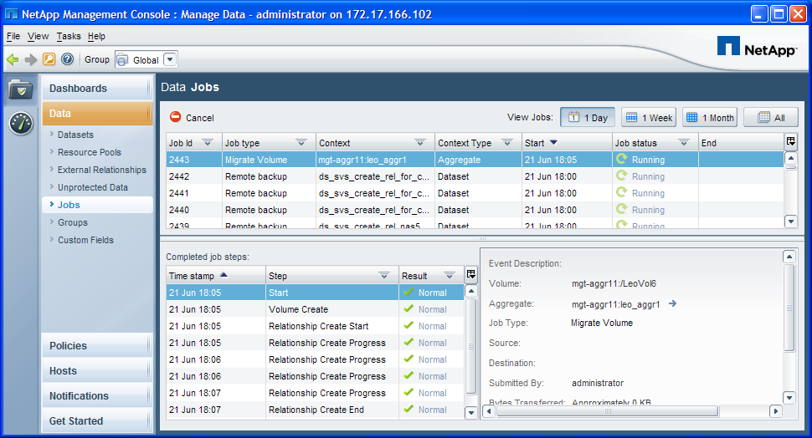

The job should be complete successfully.

