What I need to do
On a client’s device I need to create a vfiler and move some existing volumes to it and assign the hostname and ip’s currently assigned to the default vfiler to this new vfiler. And of course as a result of this I need to assign a new IP/hostname to the default vfiler. No idea how to do this hence I have set up a 7-mode sim as close as possible to the way this clients device is configured so I can find out

In the real world we are running CIFS and this will be terminated before I start this work and we will run the cifs setup command on the new vfiler when created and the existing volumes that are shared are assigned to it.

Where I am at
I have a default filer after enabling the Multistore feature and to copy the clients configuration I need to do this work on in real life I have created an ifgrp and added both e0c & e0d into this.

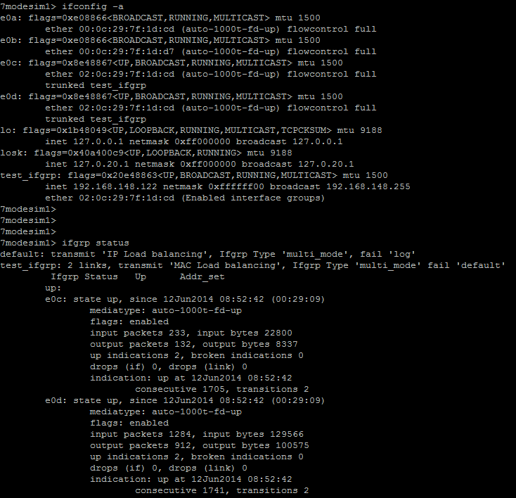

The ifgrp are part of the default-ipspace

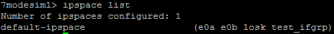

This with the exception of a couple of vlans is the way our client has their device set up.

So my next step was to change the IP of the ifgrp using ifconfig test_ifgrp <new ip> netmask <netmask> and then I will change the hostname by editing /etc/rc & /etc/hosts (Do this on both controllers) and I believe I have to do a takeover/giveback for the new objects to be created in AD. I cannot test this as I cannot get an HA pair SIM set up for some reason (again down to my stupidity probably!) so will worry about that later.

Anyway after changing the IP of the default vfiler next I ran a vfiler create command as follows and used the old default vfiler IP.

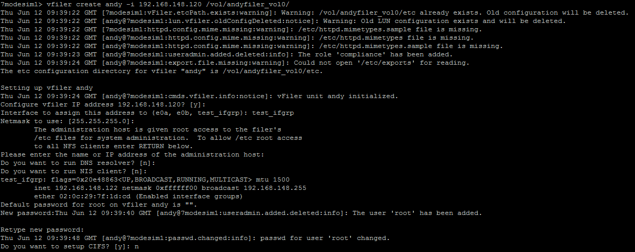

And this created a nice new vfiler called ‘andy’ which I can ping from the default vfiler and my desktop, I can also connect using the vfiler context andy command but I cannot connect to it via putty from my desktop and this is where my confusion lies.

Have I missed something that would stop me from being able to connect to this new vfiler directly? Or is this something you would expect in the simulator but in real world it would work?

So if anyone wouldn’t mind helping me try and understand where I have gone wrong that would be much appreciated.

